

NISAR SDS On-Demand System User Guide

v11

Sep 1, 2023

Max Zhan, Jeff Pon, Jimmie Young

Paper copies of this document may not be current and should not be relied on for official purposes.

| Jet Propulsion Laboratory  California Institute of Technology  Pasadena, California | National Aeronautics and  Space Administration |
| --- | --- |

**Signature Page**

| **Prepared by:** |  |  |
| --- | --- | --- |
|  |  |  |
| Max Zhan/Jeff Pon |  | Date |
| NISAR SDS PCM Developer/ NISAR SDS SE |  |  |

| **Approved by:** |  |  |
| --- | --- | --- |
| Gerald Manipon |  | Date |
| NISAR SDS PCM CDE |  |  |
|  |  |  |
| Helen Mortensen |  | Date |
| NISAR SDS System Engineer |  |  |
|  |  |  |
| Laura Jewell |  | Date |
| NISAR SDS System Engineer |  |  |
|  |  |  |
| Cecilia Cheng |  | Date |
| NISAR SDS Manager |  |  |
|  |  |  |

Document Change Log

| **Date** | **Version** | **Section** | **Description of Changes** |
| --- | --- | --- | --- |
| 2020/08/21 | v1 | 2.8 | * Initial content for R1 : Example notebook walkthrough |
| 2020/08/27 | v2 | All | * Transition content to JupyterHub |
| 2020/10/22 | v3 | N/A | * Removed incorrect D# * Updated NISAR SDS Mgr * Update TOC |
| 2020/12/07 | v4 | 2.2.6 | * Addition of topsStacks notebook discussion |
| 2020/12/16 | v5 | 2.2.3  2.2.5  2.3 | * Remove unneeded awscli install * Add missing figures of output * Addition of JupyterLab & Git extension discussion |
| 2021/02/05 | v6 | 2.3  2.4  2.2.x | * Insertion of section discussing execution of notebooks at scale * Move former section 2.3 down * Changes resulting from repository clean-up. |
| 2021/03/24 | v7 | All | * Rework after repository cleanup and related notebook changes (e.g. output directory) * Incorporate L. Jewell’s feedback * Incorporate H. Mortensen’s feedback * Add section on topsApp execution at scale * Update topsStack discussion for orbit retrieval |
| 2021/09/01 | v8 | All | * Kernels and User-local environment discussion * Updates for example notebook content * Addition of new example notebooks * OpenSARLabs migration notes |
| 2023/04/24 | v9 | All | * Reformatted sections and text to bold key points and terminology. Reworked some paragraphs into bullet points instead. * Add sections for creating the base environments and kernels for running the example notebooks. |
| 2023/08/17 | v10 | All | * Updated sign-on links, Github repo links, and Mozart IP address for ST, IOT, and ADT OD-SDS |
| 2023/08/23 | v11 | All | * Merged in missing changes from v9 update, including formatting and rephrasing changes. * Removed extraneous detailed information about conda/kernel background meant for developers and left just the information needed by on-demand users to select conda/kernel * Cleaned up the jupyter notebook 2.4.1 section to remove manual UI enabling description since it automatically logs in with the UI now |

LRR # LRR055460

TBC and TBD Log

| **Category** | **Total Occurrence** |
| --- | --- |
| TBC | 0 |
| TBD | 0 |

| **Section/Page** | **Description** | **Due Date** |
| --- | --- | --- |
|  |  |  |
|  |  |  |
|  |  |  |
|  |  |  |
|  |  |  |
|  |  |  |

# 

Table of Contents

1 Introduction 8

1.1 Overview 8

1.2 Scope 8

1.3 Reference Documents 9

2 Operations 10

2.1 Prerequisites 10

2.2 Accessing jupyterhub 10

2.2.1 Server Access 11

2.3 Conda environments 12

2.3.1 Notebook kernels 12

2.3.2 Creating the conda environments 13

2.4 Obtaining and running the example notebooks 18

2.4.1 Notebook #0 - Create Environments 21

2.4.2 Notebook #1 - Introduction 22

2.4.3 Notebook #2 – Datasets 29

2.4.4 Notebook #2.1 – Datasets w/ geospatial and time filtered queries 35

2.4.4.1 getExtentFromOGRFile() 37

2.4.5 Notebook #3 - The ISCE3 SLC Formation SAS 37

2.4.6 Notebook #4 - DEM Notebook through Papermill 43

2.4.7 Notebook #5 – Tunable Parameters 48

2.4.8 ARIAtools 52

2.4.9 topsStacks – Sentinel-1 TOPS stack processor 56

2.4.10 Cleaning up 67

2.4.11 Additional Notebooks Available 70

2.4.12 Compatibility of notebooks from OpenSARLabs 71

2.5 Executing Notebooks at Scale – A Simple Example 71

2.5.1 Prerequisites 71

2.5.2 notebook-pge-wrapper: Project Initialization 72

2.5.3 Creating the Project Repository 72

2.3.4 The example notebook 74

2.5.4 2.3.5 Generating the Job Files 77

2.5.5 2.3.6 Executing the notebook PGE 81

2.3.7 A More Representational Notebook for At-Scale Execution 84

2.4 JupyterLab 85

2.5.6 2.4.1 Enabling JupyterLab 85

2.5.7 2.4.2 The Toolbar 86

2.5.8 2.4.3 Viewing cell tags 87

2.5.9 2.4.4 Git Extension 87

# 

# Introduction

The NISAR Science Data System (SDS) provides an On-Demand environment (also referred to as an Algorithm Development Environment, or ADE); a technology stack(s) supporting Jupyter Notebooks, to the NISAR Science Team to assist in the execution of existing science data processing algorithms under varying input parameters (a scenario of “bring your own parameters”) as well as the development and execution of new algorithms (a scenario of “bring your own code”). The ADE enables rapid prototyping with immediate feedback using smaller datasets as well as execution at scale over larger, more real-scale datasets.

## Overview

To provide a cloud-based ADE, JupyterHub is employed to provide Jupyter Notebook Servers to multiple users. By providing access to various data access/SDS application programming interfaces (APIs) and other packages (such as ISCE2, ISCE3, etc), this environment becomes conducive for development of Product Generation Executives (PGEs), Cal/Val activities, On-Demand analysis and other ‘what-if’/exploratory scenarios.

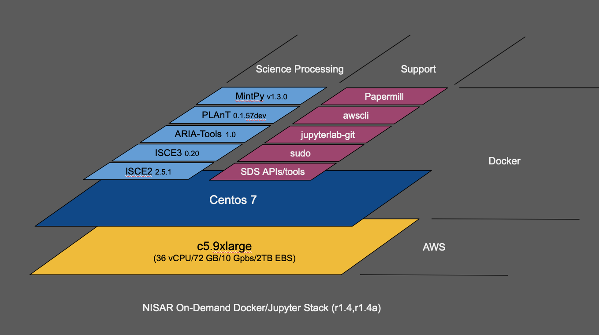

*Figure 1* : The ADE Environment (r1.4.x – 2021/03/24)

## Scope

This guide provides an overview of the JupyterHub based ADE and basics on how to use it in conjunction with data access APIs, such as the HySDS Pele API to access datasets stored within the PCM environment and science data analysis packages such as ISCE3 by going through the set of example notebooks.

## Reference Documents

The following references provide additional information that is relevant to the content of this document.

1. [NISAR PCM Software Design Document (SDD)](https://drive.google.com/a/jpl.caltech.edu/open?id=178U0U6F1VwJ-bm3kkCxsYbQQqi4V5t-2TrKFhmMEBX4), Baseline, February, 2020
2. [NISAR PCM Deployment Guide](https://drive.google.com/a/jpl.caltech.edu/open?id=18gXaavfeuu3VC-ry7TgLb0Q0gYb3OPbxo9x_2moiOP8), Baseline, February, 2020
3. [Project Jupyter](https://jupyter.org/) – for more information on Jupyter Notebooks, JupyterLab, JupyterHub, etc.
4. [Jupyter/IPython Notebook Quick Start Guide](https://jupyter-notebook-beginner-guide.readthedocs.io/en/latest/index.html) (readthedocs.io)
5. [Papermill Documentation](https://papermill.readthedocs.io/en/latest/)
6. [Pele (data access API) README](https://github.com/hysds/pele)
7. [Geospatial Data Abstraction Library (GDAL)](https://gdal.org/index.html), specifically [gdalinfo](https://gdal.org/programs/gdalinfo.html) and [gdal_translate](https://gdal.org/programs/gdal_translate.html) utilities

# Operations

## Prerequisites

You will need the following information in order to proceed:

| **Info** | **Description** | **Example** |
| --- | --- | --- |
| JupyterHub Username and Password | Credentials to access the NISAR JupyterHub instance. |  |
| AWS Username and Password | Credentials to access the example NISAR datasets stored in a global-read S3 bucket. |  |
| Mozart IP Address | IP address of the mozart instance which serves as the endpoint to the Pele (data access) API. This is provided by the PCM system administrator. | ST: 172.31.29.154  IOT: 100.104.65.36  ADT: 100.104.10.127 |

*Table 1* Prerequisites for the examples presented in this document.

ST OD-SDS is publicly accessible as long as you have an ST OD-SDS account on the system..

JPL intranet or VPN connection is required for IOT and ADT OD-SDS system access.

In order to access datasets hosted at the UAF DAAC you will need an Earthdata login which can be obtained at: <https://urs.earthdata.nasa.gov>.

Jupyter Notebooks, formerly known as iPython Notebooks are based on the Python programming language. While facilities exist by which notebooks can be developed in other languages (a list of open-source contributed kernels can be found [here](https://github.com/jupyter/jupyter/wiki/Jupyter-kernels)), the default language remains Python, which is also the predominant language for science data processing. With this in mind, a working knowledge of Python is strongly suggested if not mandatory.

## Accessing jupyterhub

A set of notebooks are provided to demonstrate; how to establish and test access to the Pele Data Access API (which provides an interface to the datasets stored in the local processing environment), query datasets, exercise science data processing packages (such as ISCE 2/3, MintPy, ARIATools and PLAnT) and run a parameterized notebook at scale.

### Server Access

**Summary**: This section takes you through logging into and accessing the JupyterHub environment and selecting the proper Jupyter Server image type, provides a brief summary of the JupyterHub user interface and information about the git repository containing the example notebooks. Read this if you are unfamiliar with the NISAR ADE JupyterHub and or the example repository.

In a web browser, navigate to the NISAR Jupyterhub instance and log in using your username and password:

ST OD-SDS: <https://nisar.jpl.nasa.gov/ondemand/>

IOT OD-SDS: <https://nisar-ondemand-iot.jpl.nasa.gov>

ADT OD-SDS: <https://nisar-adt-ondemand.jpl.nasa.gov/>

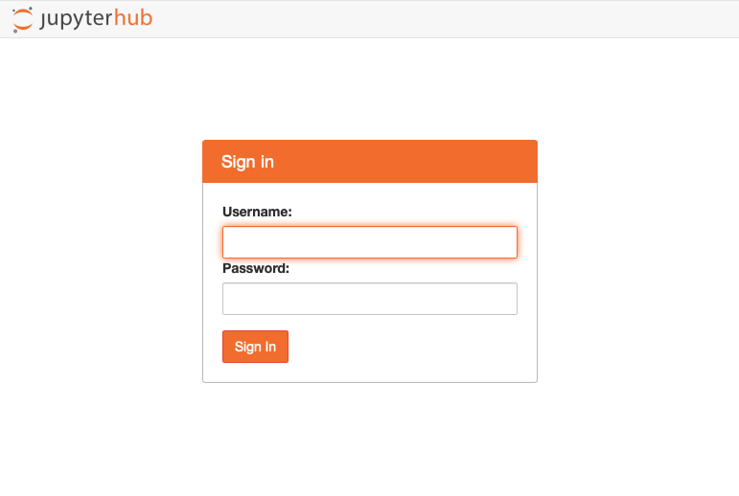

Slect **Base NISAR On-Demand ADE - CPU - DEFAULT** (or similar) and press **Start:**

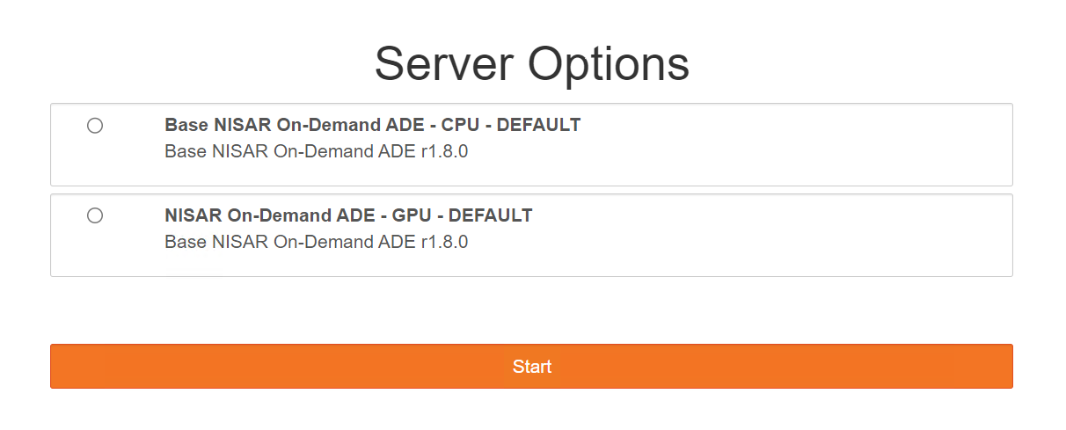

Note that the list of available servers may vary from time to time but the suggestion is to select the highest version of ‘NISAR On-Demand ADE’.

As the Jupyter server is being initialized a progress screen is displayed, this should complete in less than a minute:

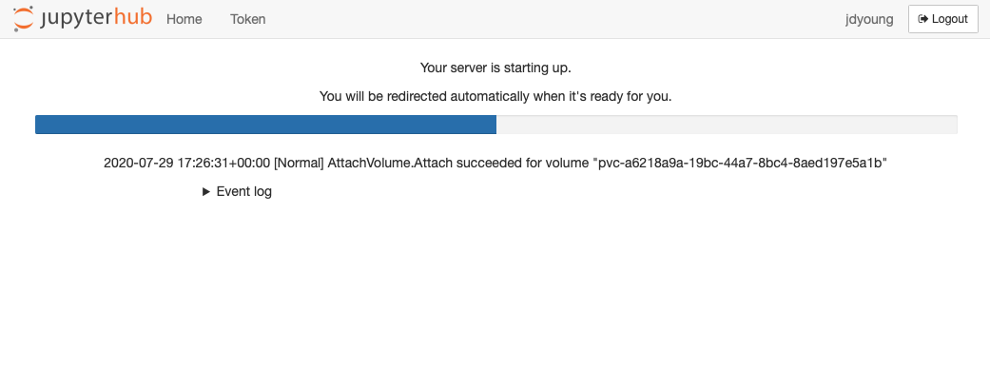

Once the server is started, the current contents of your home directory (**/home/jovyan/**) will appear in the **File Browser**. If this is your initial log-in to the system or you have yet to add any content, this directory will be mostly empty.

## Running the example notebooks

A set of notebooks are provided to demonstrate; how to establish and test access to:

* Pele Data Access API to Query datasets
  + The Pele API provides an interface to the datasets stored in the local On-demand processing environment intended primarily for IOT and ADT on-demand users.
  + Note that science on-demand users may also use the Pele API to discover and interface with datasets stored locally in the On-demand rolling storage system, but Science on-demand users are recommended to send their output products to ASF DAAC S3 buckets where data may persist and be discoverable via asf_search python module or Vertex GUI.
* Exercise science data processing packages (such as ISCE 2/3, MintPy, ARIATools and PLAnT)
* Run a parameterized notebook at scale.

These notebooks and additional tools can be retrieved online from the **isce-framework/sds-ondemand** repository. To do so, follow the steps outlined below:

1. Press the **Git Clone** button (tooltip will say “Git Clone”).
2. In the **Clone a repo** pop-up, copy-and-paste in the following URL: [**https://github.com/isce-framework/sds-ondemand.git**](https://github.com/isce-framework/sds-ondemand.git)
3. Press the **Clone** button.
4. After downloading, the **sds-ondemand** folder should appear on the left in the **File Browser** tab.

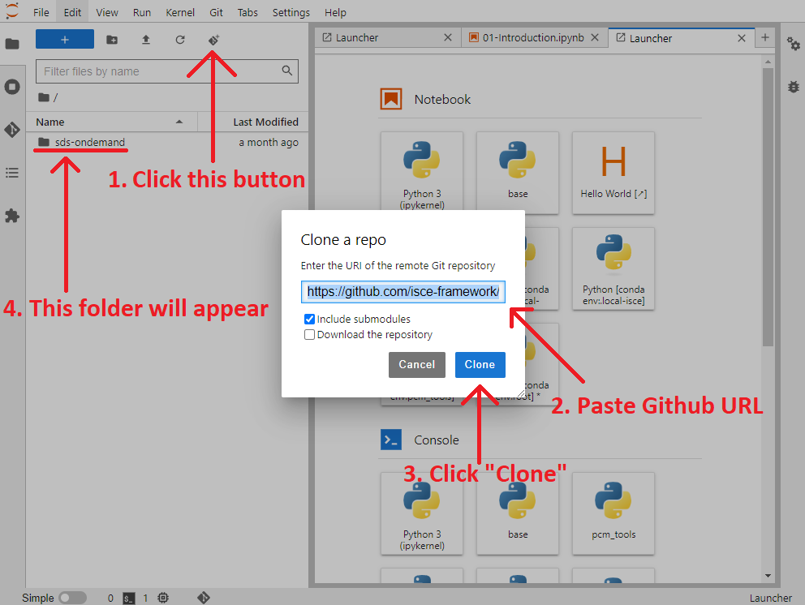

Alternatively, if you are familiar with Linux, you can also **open a Linux terminal** and clone the repository that way (**git clone https://github.com/isce-framework/sds-ondemand.git**):

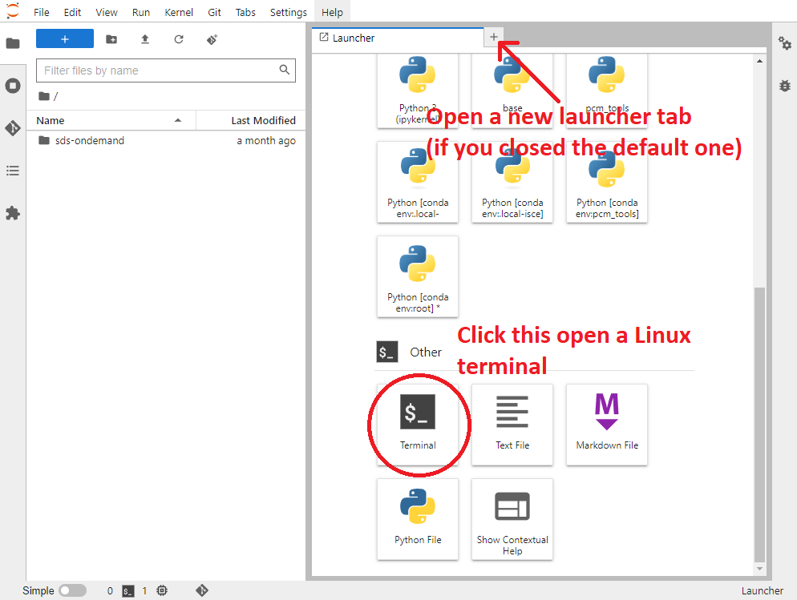

You can also run any other installed linux commands as desired.

Once cloned, you can double-click the **sds-ondemand** folder in the **File Browser** tab to view its contents, or navigate to any of its subfolders. You should see something similar to this:

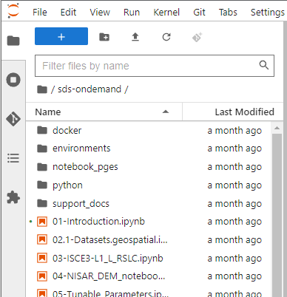

In the subsequent section, for users **unfamiliar with Jupyter Notebooks**, we will use the following terminology:

* **Notebook:** Shorthand for **Jupyter Notebook**. Refers to a **.ipynb** file which intersperses text cells (purely for descriptive purposes) with Python code cells.
* **Kernel:** The **Conda environment** the notebook runs under. Many sample notebooks have library dependencies so the kernel needs to be set with the proper conda env to able to run.
  + You can **restart** the kernel using the **Reload button** at any time to start from a clean state or change to a different kernel.
* **Cells:** Editable sections of the notebook which can contain either text or code.
  + Cells can be **executed** by selecting them via **Left Click** and then pressing the **Run** button (or **Shift+Enter**). Multiple cells can be selected at once.
  + When a cell is not selected, you select all cells by pressing **Ctrl+A**.
  + Cells can be **executed in any order** and **any number of times**, but most notebooks will prefer to **initially execute** its cells from **top-to-bottom**.
  + Initially executing cells out of order **may lead to unexpected errors**.
  + To reset the state of your notebook, **restart the kernel** via the **reload button**.
* **Markdown Cell:** A description cell written in the text formatting language **Markdown**.
  + Executing the cell will display it as formatted text.
  + Markdown cells will typically document the purpose of the code cells underneath them.
* **Code Cell:** A cell which contains **Python code** that can be executed to change the state of the notebook.
  + May also contain **bash commands** as well.
  + May also be referred to as **steps.**

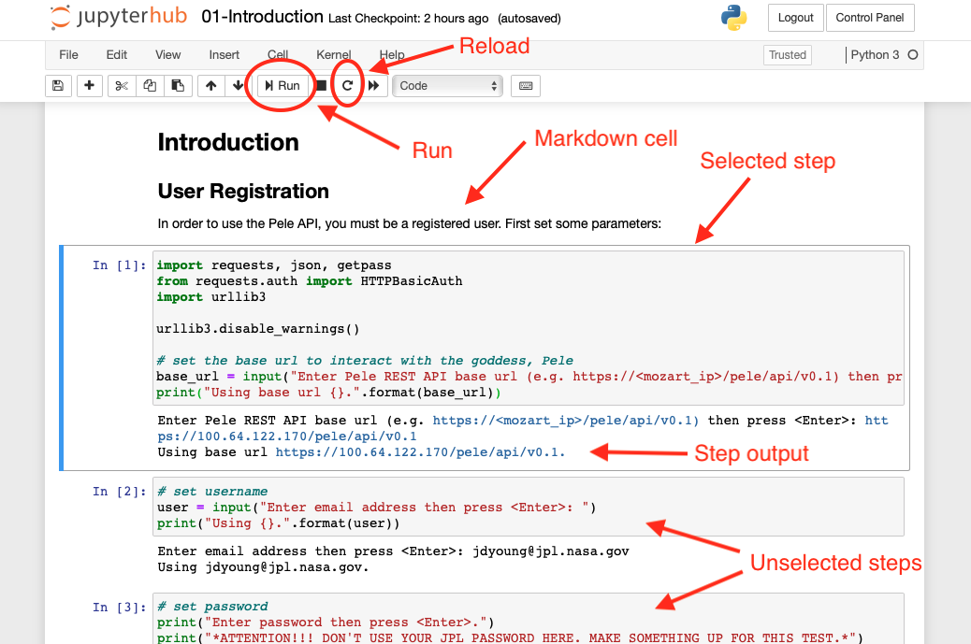

To execute a cell, **Left Click** within the code box to highlight it (surrounded by a box) as shown below, then press the **Run button** (or **Shift+Enter**) at the top. When a cell has fully executed, the subsequent cell will be automatically selected.

The keyboard up/down keys can also be used to navigate between cells.

### Notebook #0 - Create Environments

This notebook creates **Conda environments** and adds them as **kernels**, which we will use to run the subsequent notebooks. **Create_Environments.ipynb** is located under the **environments/** subfolder:

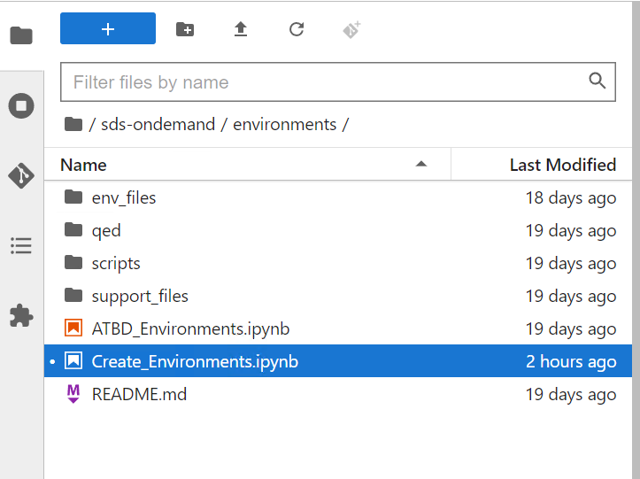

To run this notebook, **double-click** the file named **Create_Environments.ipynb** in the **File Browser**. This will open a new tab displaying the contents of the notebook:

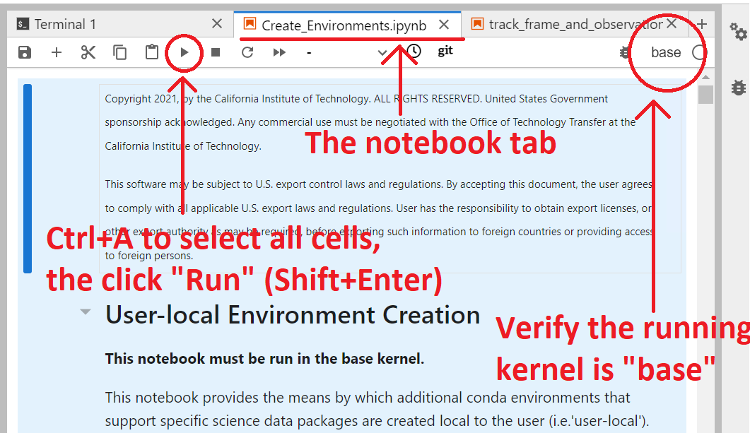

To run the notebook, select all cells in the notebook using **Ctrl+A** and then press the **Run** button (or **Shift+Enter**). This will execute all cells in the notebook in order, from top-to-bottom. As the notebook executes, the basic environments will be added to the list of kernels.

In the subsequent notebooks, a markdown cell will **specify which Kernel should be selected to run that notebook.** When you open the notebook, one of these kernels should **already be** **selected by default**. You can view the list of available kernels by clicking on the name of the kernel in the **top right corner** of the notebook tab:

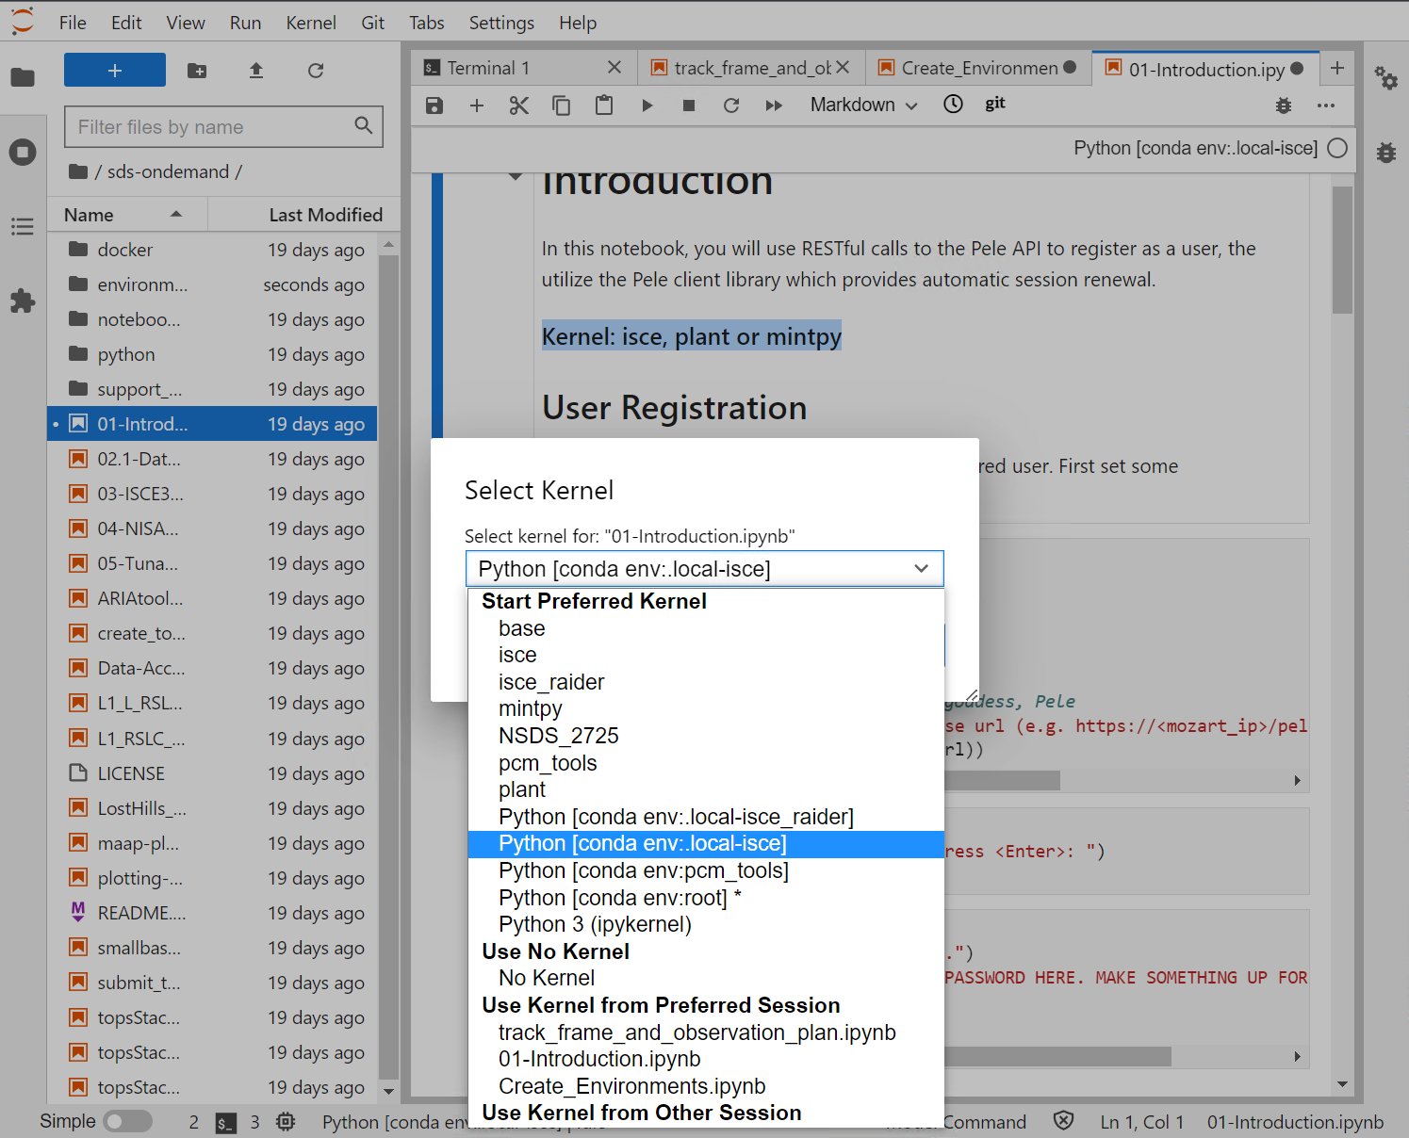

### Notebook #1 - Introduction

**Summary:** This section presents the notebook that provides an introduction into the Pele Data Access API, registers you as a user for the API and discusses the associated client API library which transparently manages session refreshes on your behalf. Read this if you are unfamiliar with this API and intend to access datasets stored in the local PCM environment. Note that user registration is a prerequisite for the second notebook in the next section.

**Kernel:** *any*

This notebook registers you as a Pele API user, sets up automatic authentication by creating a .netrc file and installs necessary dependencies on your server.

**Step 0 - Open the notebook**

Within the **sds-ondemand** directory, **double-click** the file named **01-Introduction.ipynb**. This will open a new tab displaying that notebook.

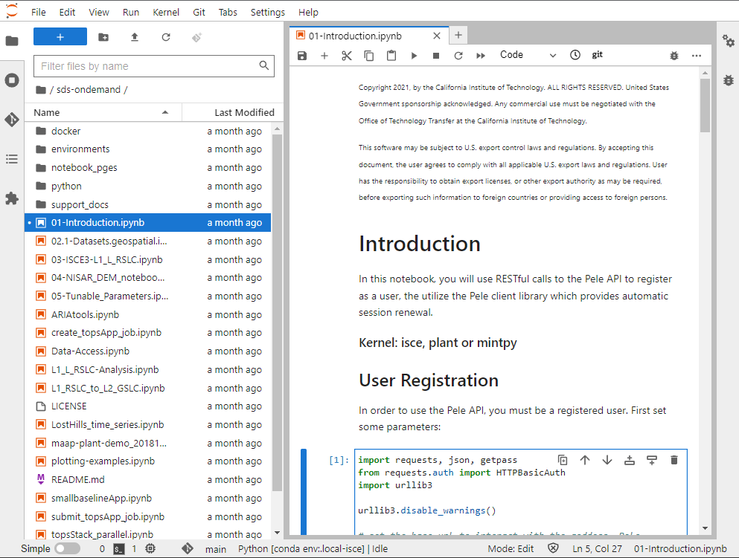

**Step 1 - Set the endpoint for the Pele API**

The Pele API endpoint is the **Mozart IP address** appended with “**/pele/api/v0.1**”. When this step is run, enter this value into the prompt (e.g. **https://100.104.65.36/pele/api/v0.1**).

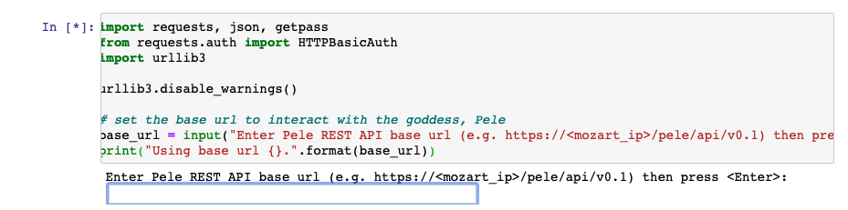

**Step 2 - Set your username**

Running this step prompts you for your username, which should be your **JPL email address**. The registration confirmation code (see step 4 below) will be sent to this address.

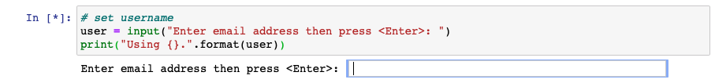

**Step 3 - Set your password**

This step prompts you for the password to use when accessing the Pele API. As noted by the prompt, **DO NOT use your JPL password**. Create a new one solely for use in these notebooks.

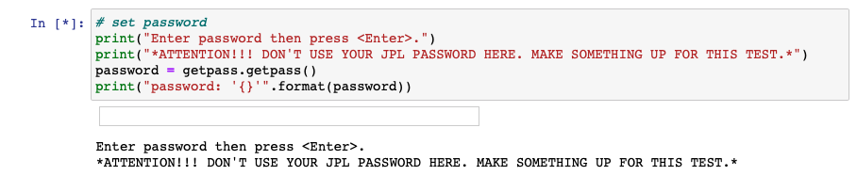

**Step 4 - Attempt to log in**

This step attempts to log in to the Pele API with the username and password you’ve specified. Since you have not yet registered (see Step 5), **this request should fail** with a 401 status (Unauthorized), which is asserted at the end of the code block. The figure below shows what should appear after the step is executed.

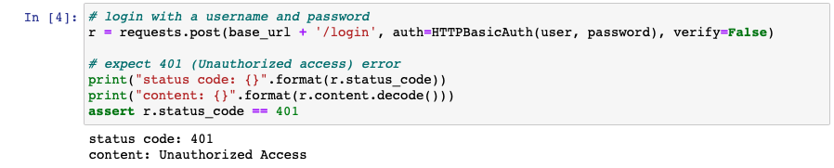

If the request hangs and throws an exception (indicated when the output is highlighted in red), then the **IP address** entered in Step 1 is **either unavailable or incorrect**. If that is the case, repeat Step 1 and check that the IP address entered is pingable, then return to this step.

**Step 5 - Register w/ the Pele API**

A request to register you is sent to the Pele API in this step. An email message is sent to the email address you entered in step 2 which contains the confirmation code that is entered in step 6.

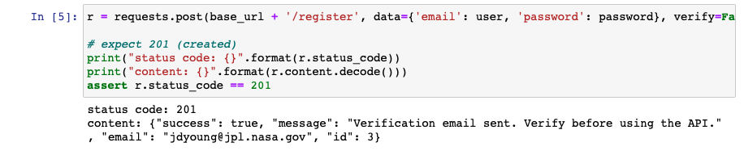

The markdown cell following the above step describes what the email message will look like. Select and copy the confirmation code in the received message.

**Step 6 - Confirm the registration**

This step prompts you to enter the confirmation code you received in the email message generated as part of executing step 5 above.

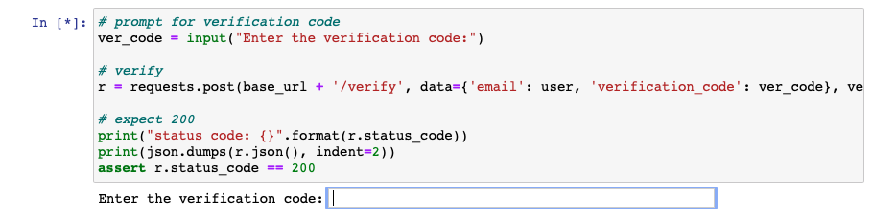

Once the registration is confirmed, the following will be displayed below the cell:

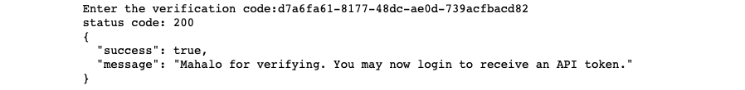

**Step 7 - Login and obtain an API token**

Once you log into the Pele API, an API token is generated and returned. It is then passed back to the API in subsequent requests as proof of authentication. This step uses the now confirmed username and password to obtain the token, which is displayed and assigned to a variable for downstream use.

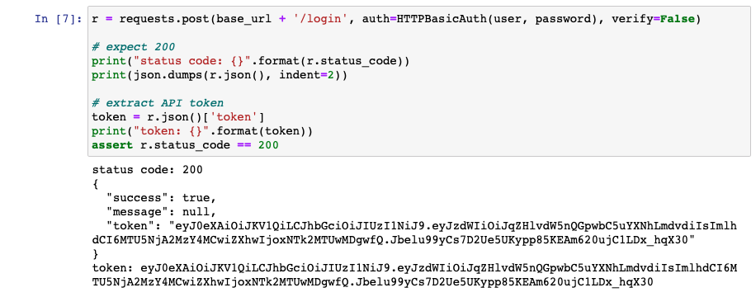

**Step 8 - Issue a Pele API request w/o the API token**

To demonstrate what occurs if a restricted Pele API request is issued without a (valid) API token, this step attempts to make such a request (a simple echo command) which will generate a 401 status.

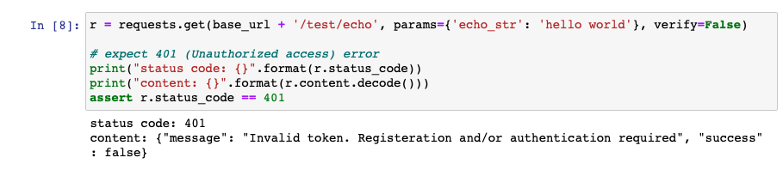

**Step 9 - Issue a Pele API request w/ the API token**

This step issues the same request as in step 8 but passes in the API token in the header parameter *X-API-KEY*.

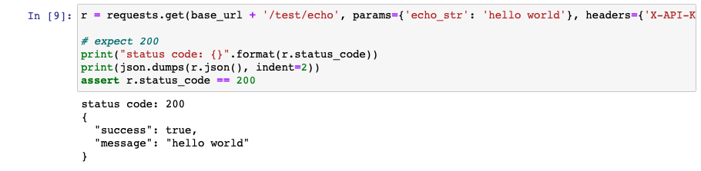

**Step 10 - Automatic token refresh**

The markdown cells following step 9 discuss token expiration and the steps to take to have the token automatically refreshed upon expiration through the use of a .netrc file. This step populates this file with your username and password, associating it with the Pele API endpoint (i.e. mozart) host.

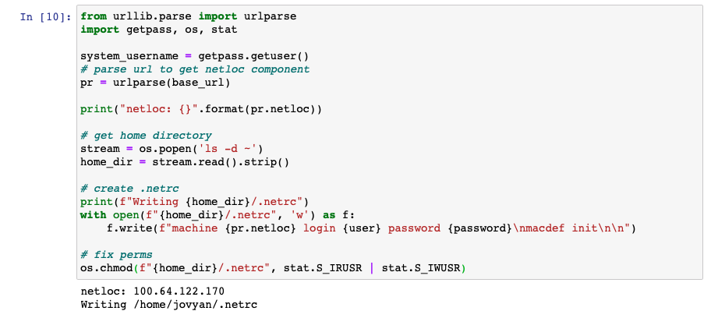

**Step 11 - Install the Pele client library**

This step issues a shell command to install the Pele python client library and its dependencies. The client library is what will take advantage of the .netrc file created in the previous step. As long as the Jupyter server remains running, these dependencies will exist across notebooks run on the same server instance.

The output window displays the results of the *yum install* and *pip install* commands.

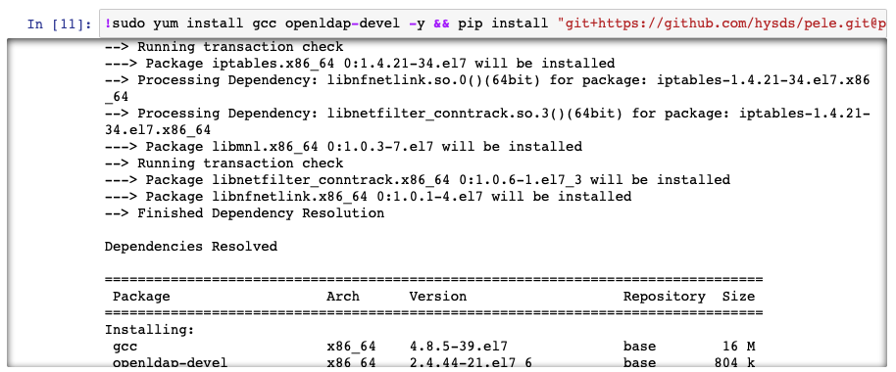

**Step 12 - Exercise the Pele API and .netrc file**

This step uses the *PeleRequests* client class to issue the same *echo* commands that were previously sent using the *urllib* library. Note the absence of an explicit passing of username and password and/or an API token. Logging in and token management are handled behind the scenes using the .netrc file created in step 10.

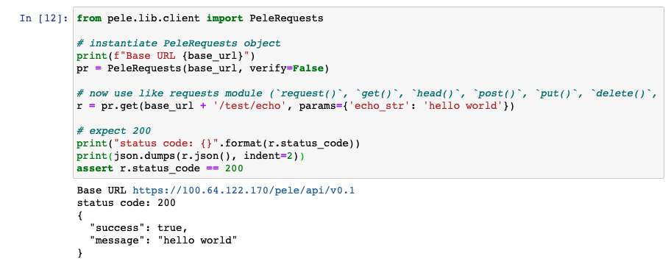

**Step 13 - Demonstrating Pele API rate limiting**

To prevent Denial of Service (DoS) attacks, the Pele API imposes a rate limit of 10 calls per second. This step exercises this limit.

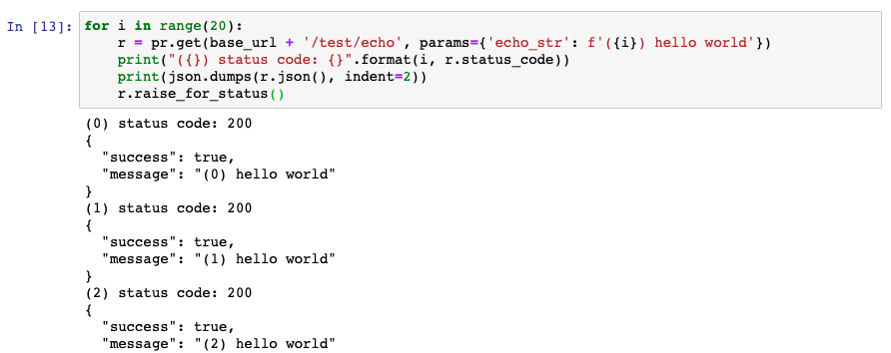

At the bottom of the output, you will see the error generated by exceeding the rate limit:

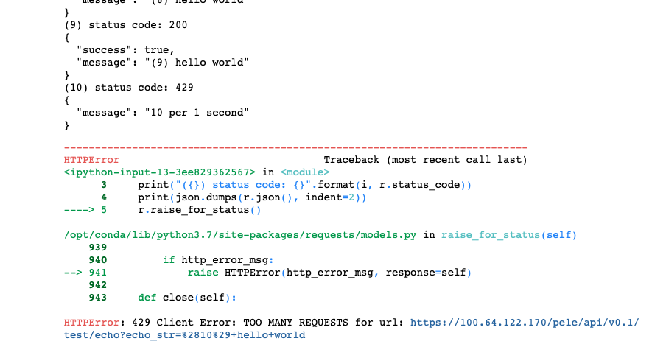

**Step 14 - The backoff module**

The backoff module/annotation can be used to automatically retry function calls on exception. This step installs this module.

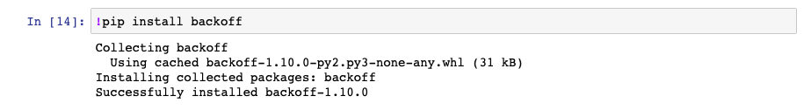

**Step 15 - Using backoff**

Looking at the backoff annotation in this cell, the *echo* function will be retried on an *HTTPError* and performed on an exponentially decreasing frequency, up to 3 tries.

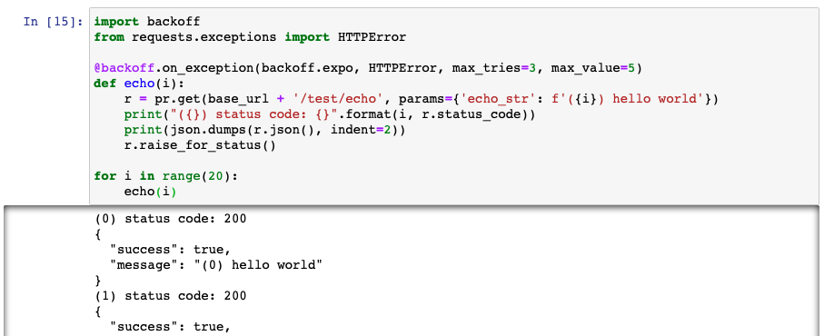

Once the rate limit has been reached, the output will show the retries:

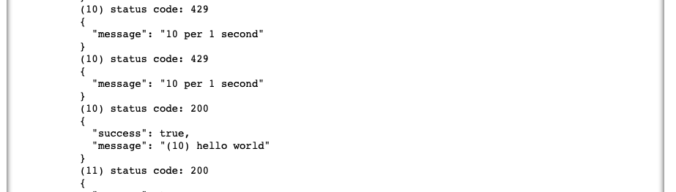

The remaining calls should succeed now that the rate limit threshold has been reset.

Congratulations, you have successfully completed the first notebook. Return to the primary Jupyterhub browser tab that lists the contents of the nisar-on-demand-use-cases directory.

### Notebook #2 – Datasets

**Summary:** This section discusses the use of the Pele Data Access client API to access PCM-environment-local datasets. It assumes you have gone through the registration process identified in the previous section. Read this if you will be accessing datasets local to the PCM-venue and are unfamiliar with the client-side Pele API.

**Kernel:** *any*

This notebook will demonstrate how a dataset is queried and downloaded through the HYSDS data access api (also known as *‘Pele’*). Hopefully you are establishing a familiarity with using the general notebook interface at this point, so discussion of some of the steps that are repeats of those in the first notebook will be brief.

Dependencies from Notebook #1 - The following are assumed to have been performed as part of execution of the first notebook:

* Installation of the Pele API
* Registration of the Pele API
* Creation of the .netrc file (optional)

**Step 0 - Open the notebook**

Click on **02-Datasets.ipynb** to open the notebook in a new tab.

**Step 1 - Authenticate to the Pele API**

Set the Pele API endpoint, username (i.e. email) and password in the first three cells. Use the same values that you provided in Steps 1, 2 and 3 for Notebook 1. Since you have already registered with the API, there is no need to repeat the process.

**Step 2 - Create the .netrc file**

This step is also a repeat from the first notebook. It can be skipped over if it was performed earlier.

**Step 3 - Verify access**

Again, execute this step to verify that your access to the Pele API is working.

**Step 4 - Query for available datasets**

This step issues a GET for available dataset types through the /pele/datasets endpoint:

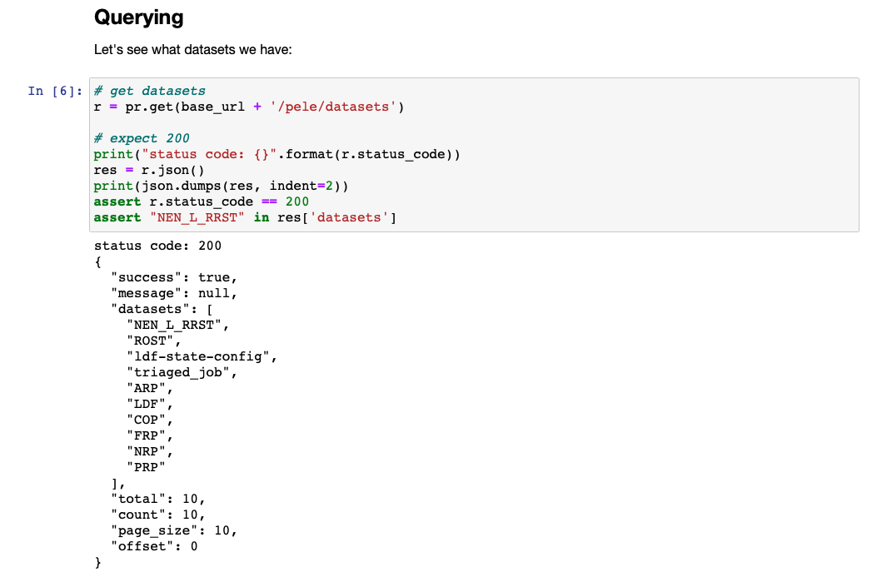

The remainder of this notebook will focus on the NEN_L_RRST dataset type.

**Step 5 - List dataset IDs**

Now a query to obtain the available IDs of the NEN_L_RRST dataset type issued, verifying that the response contains 34 ids:

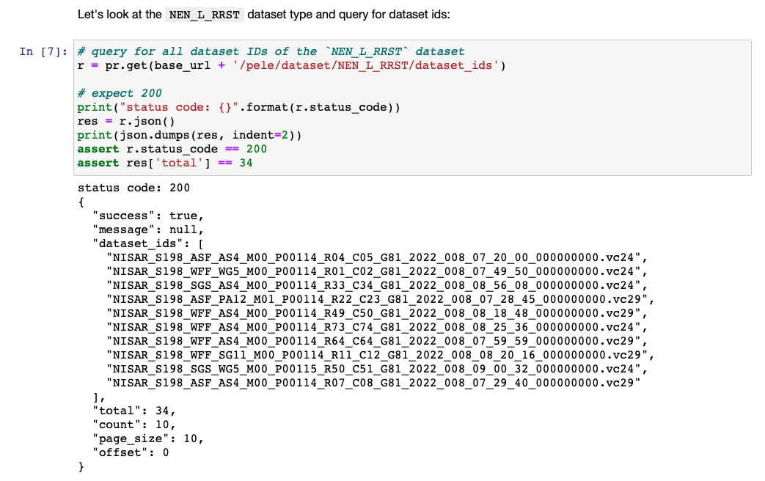

Note however that while there are 34 ids available (“total”), the API only returns a subset of 10 (“count”).

**Step 6 - Iterate to get all IDs**

This step iterates until all available dataset IDs are retrieved:

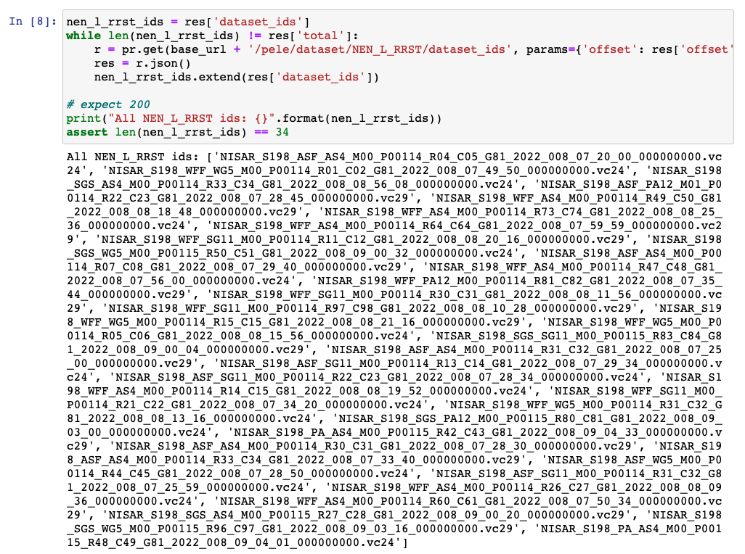

**Step 7 - Dataset metadata**

Using the first dataset ID in the list, the associated metadata is retrieved:

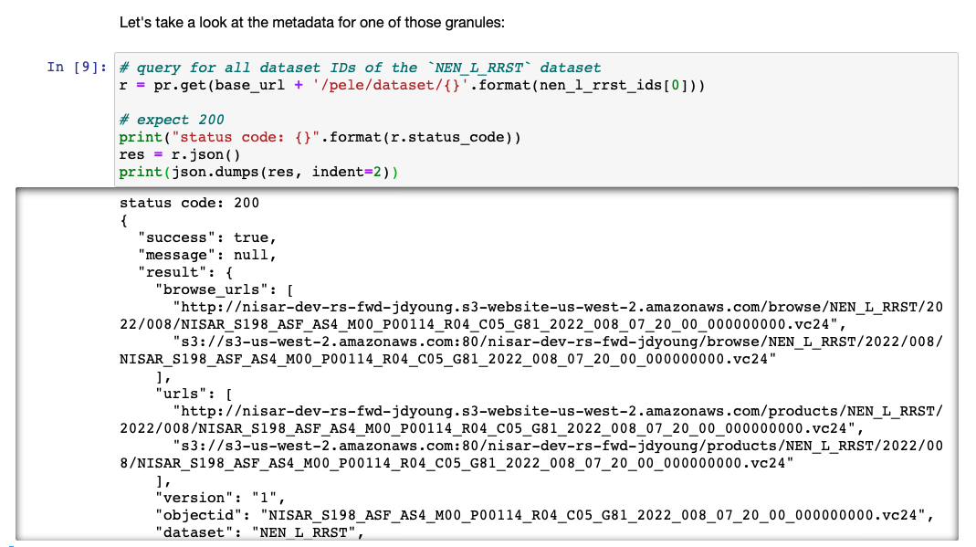

**Step 8 - Dataset URLs**

The objective of this notebook is to download the dataset from AWS S3. For this, the URL portion of the metadata is needed, which is extracted and displayed here:

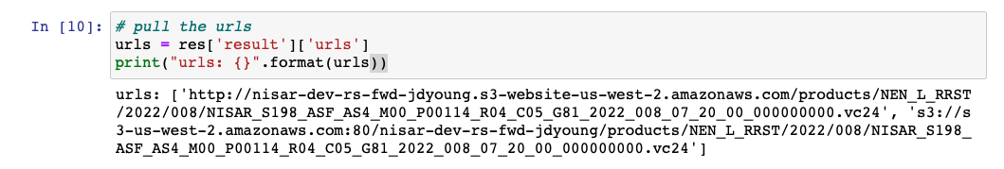

**Step 9 - Obtain the S3 URL**

There are multiple locations for this dataset, but the S3 location is of interest for download performance. Note that this cell doesn’t print the extracted location (but does assert that it exists), feel free to add the print statement if you’d like:

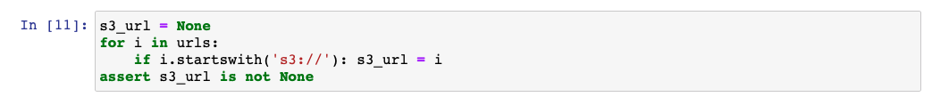

**Step 10 - Install the AWS command line**

The AWS command line will be used to download the dataset from S3, it is installed in this step.



**Step 11 - Create AWS credentials**

In order to be able to download the file from S3, the file .aws/credentials must be populated with valid values. For this, the aws-login utility is provided. As you did in setup, open (or go to the tab if it’s still available) a terminal and run the command from the nisar-on-demand-use-cases directory:

./aws-login -pub -p default -r us-west-2

When prompted, enter your JPL SSO login. You will be prompted for which role to use (if you have more than one), any is valid as the S3 bucket is open for global read.

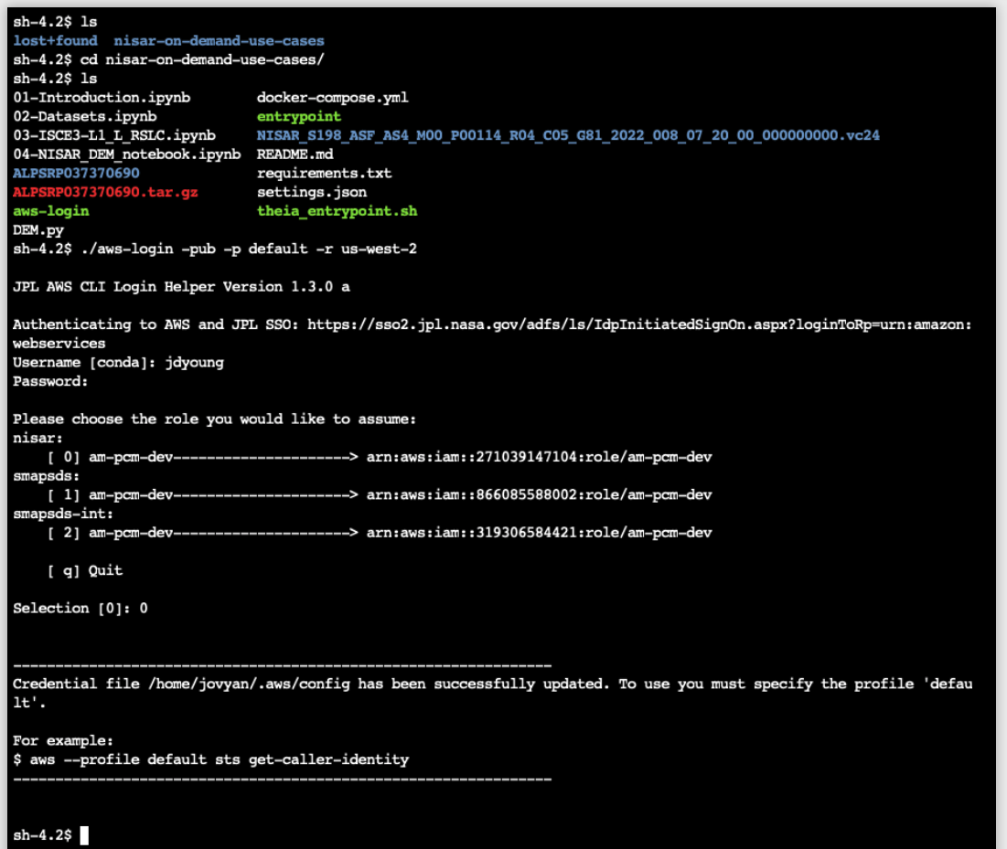

**Step 12 - Download the dataset**

Once logged in to AWS, the dataset can be downloaded:

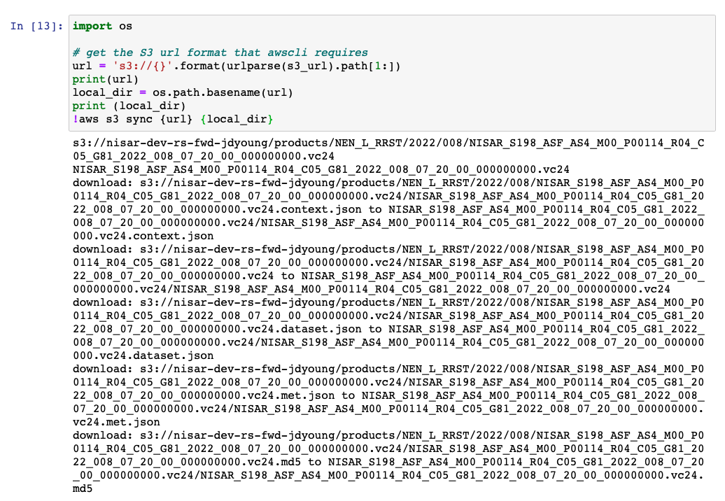

**Step 13 - Dataset files**

The files that were downloaded are now in the notebook’s file system:

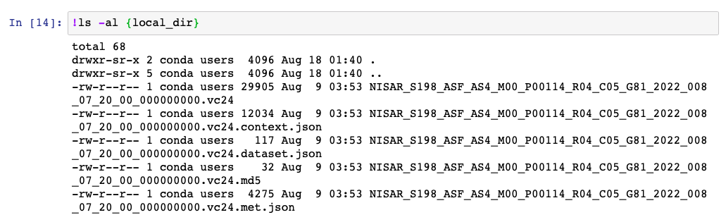

### Notebook #2.1 – Datasets w/ geospatial and time filtered queries

**Summary:** This notebook is a derivation of Notebook 2 extended to query for the target dataset using a geospatial and time filtered query.

**Kernel:** *any*

Since it is largely identical to the previous notebook, we will focus only on the differences. First off, you will notice we’re working with L2_L_GSLC datasets, as found in the fourth code cell:

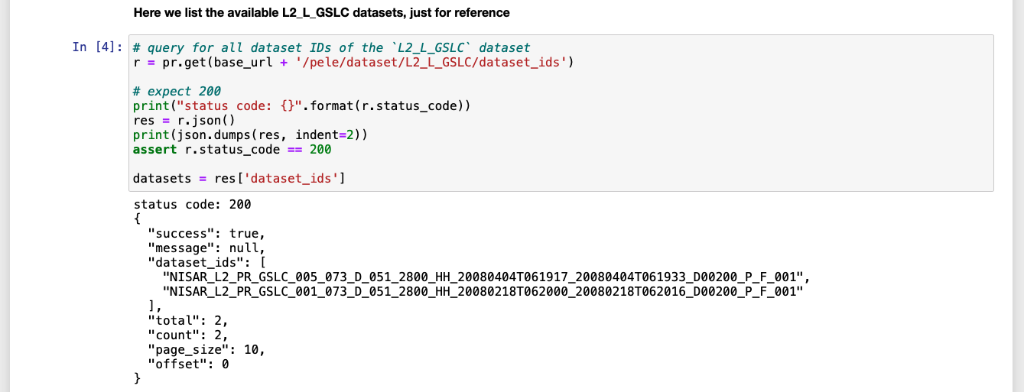

Now we will define a closed polygon (in this case, a rectangle) for which overlapping products will be returned. Additionally, we will specify a time range.

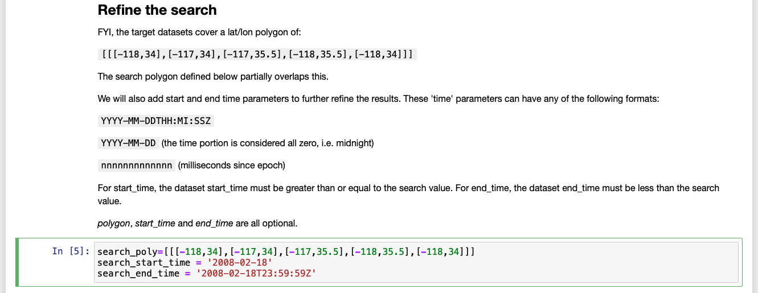

The polygon and start/end time are then submitted as part of the search request in the next cell, with one product in the result:

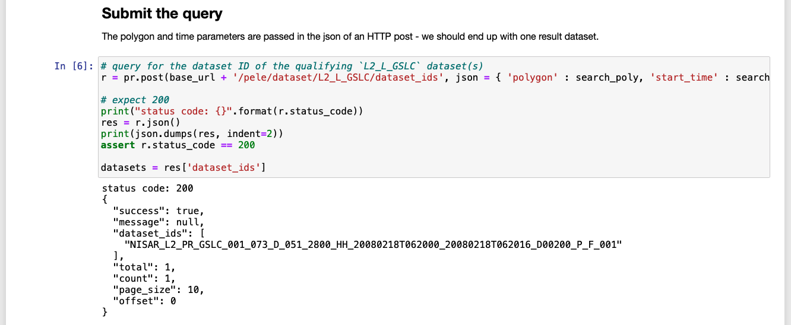

The steps for extracting the dataset URL and downloading from S3 are identical to the previous notebook so their discussion will be omitted.

#### getExtentFromOGRFile()

A helper function getExtentFromOGRFile() is available in the pele_client library. This function accepts as arguments; the name of an OGR-compliant file containing one or more layers and, an optional layer name. This function extracts from the indicated file the polygon of the identified layer (or the first layer in the file if the layer name is omitted) in the format that can be specified in a *pele* geospatial query as in the above notebook. The import for this helper is as follows:

from pele_client.client import getExtentFromOGRFile

### Notebook #3 - The ISCE3 SLC Formation SAS

**Summary:** This notebook exercises the ISCE3 Single Look Complex (SLC) Formation SAS to produce amplitude and phase plots from an input L0B (from a source as a stand-in for a NISAR data product). This notebook has no dependencies on those previous. Read this section if want an example of SLC processing and plot visualization.

**Kernel:** isce

This notebook exercises the ISCE3 Sea Level Change (SLC) Formation PGE to produce amplitude and phase plots from an input L0B. This notebook has no dependencies on those previous.

**Step 0 - Open the notebook**

Click on **03-ISCE-L1_L_RSCL.ipynb** to open the notebook in a new tab.

**Step 1 - Download the input data**

The input data is approximately 225MB and typically takes around 30 seconds to download. The output of the curl command shows the download’s progression.

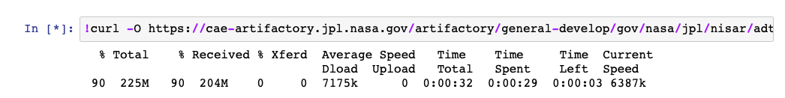

**Step 2 - Unpackage the input data**

The input data is unpackaged into the **ALPSRP037370690** subdirectory. Of primary interest is the L0B file: **input/ALPSRP037370690.L0B.h5**.

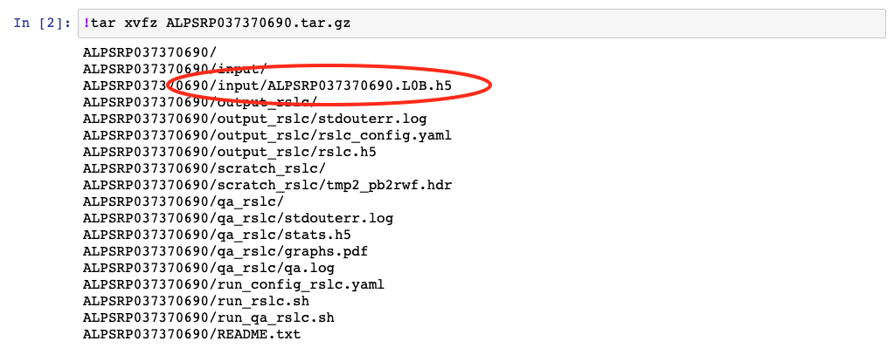

**Step 3 - Run the PGE**

The SLC Formation PGE is executed in this step. Note the second line from the last, which disables use of GPUs (Graphics Processing Units), which provide accelerated computing (at a higher cost). If your instance is GPU enabled, running the PGE through it/them dramatically increases processing speed (from several minutes down to a half minute). Comment out this line (i.e. precede it with a hash (‘#’)) prior to running this step to enable use of the GPU, as shown below.

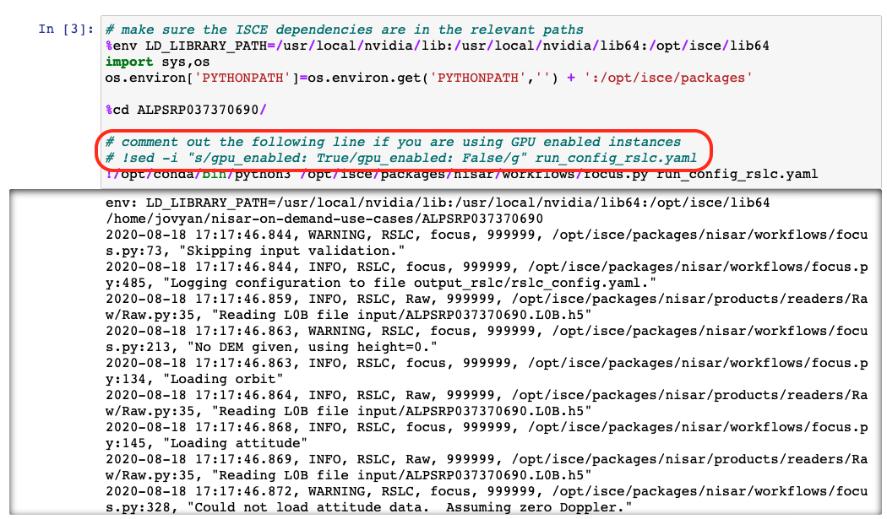

**Steps 4, 5 & 6 - Check the results**

The next three steps explore the results, captured in the file output_rscl/rscl.h5. The second of these displays the contents of the HDF5 file. The last step uses the gdalinfo utility to report on the contents in greater detail (GDAL = Geospatial Data Abstraction Library), specifically the HH processing channel.

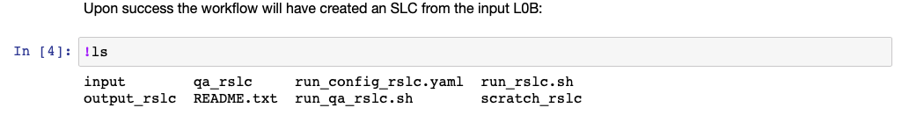

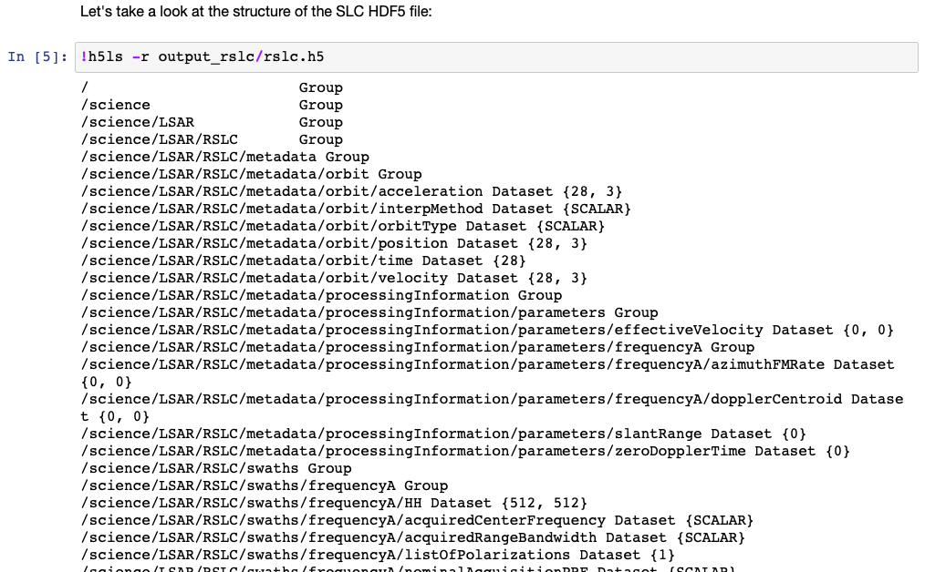

(Output of the above cell has been truncated for brevity.)

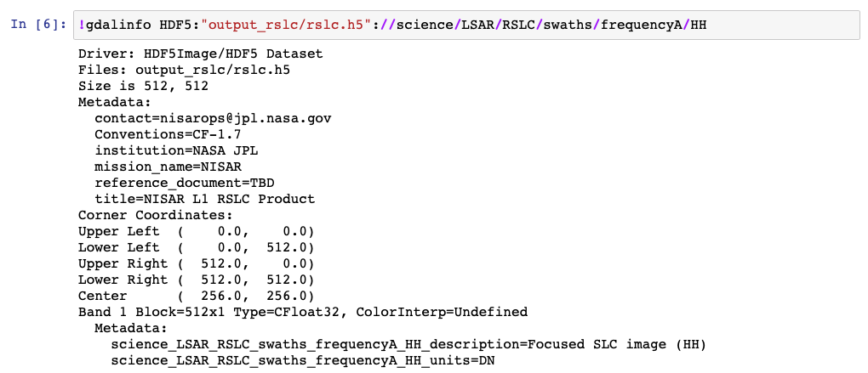

**Steps 7 & 8 - Translate the output format**

The gdal_translate utility is used to extract out the HH processing channel data converting it from HDF5 to the ENVI image format. The metadata of the translation results are then displayed.

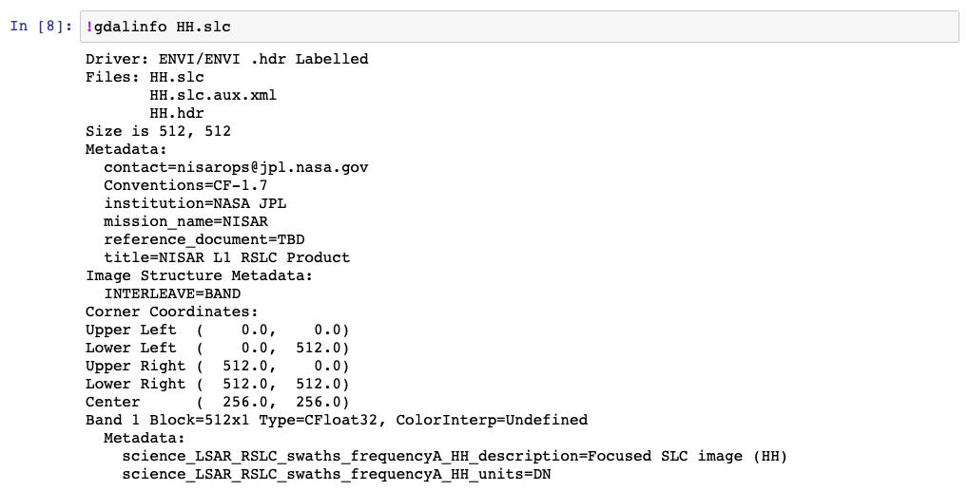

**Step 9 - Visualization**

Lastly, the translated ENVI file is displayed as amplitude and phase.

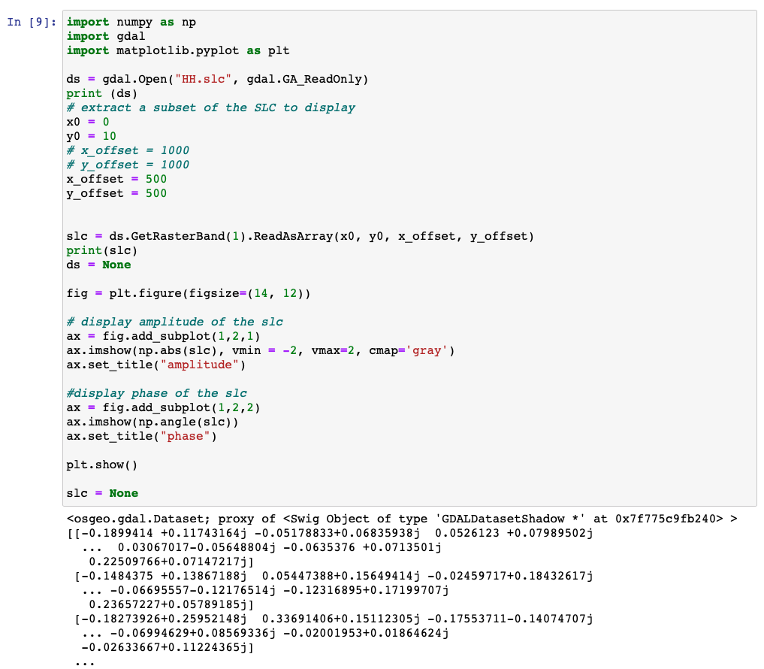

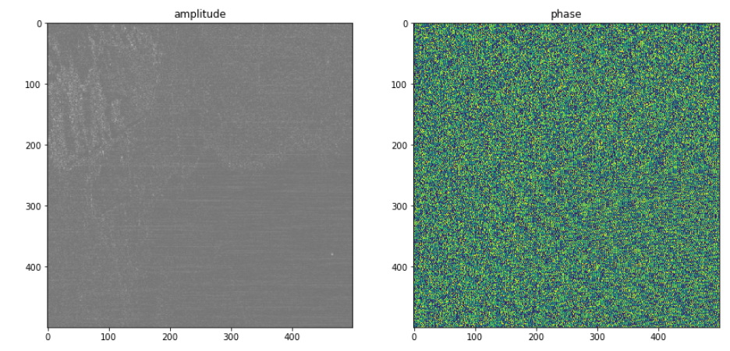

### Notebook #4 - DEM Notebook through Papermill

**Summary:** In the final notebook of this set, **Papermill** will be used to execute a **parameterized notebook** as a standalone Python executable (i.e. outside of the Jupyter kernel) to generate a DEM visualization. Standalone notebooks are expected to enable their execution as PGEs at scale. Read this section if you intend to execute notebooks stand-alone or as PCM PGEs.

More information on Papermill can be found here: <https://papermill.readthedocs.io/en/latest/>

**Kernel:** isce

**Step 0 - Open the notebook**

There are some preliminary steps that need to be performed prior to running the notebook in Papermill. Additionally, opening the notebook will permit a better understanding of what is going to ultimately occur. Click on **04-NISAR_DEM_notebook.ipynb** to open it in a new tab.

**Step 1 - Create AWS credentials**

This notebook accesses S3 to load the DEM file which requires valid AWS credentials. See step 11 of Notebook 2 for the instructions on generating or renewing these credentials.

**Parameterizing a notebook for Papermill**

It is rarely the case that a notebook is not driven by input parameters and in order to run a notebook stand-alone in the absence of user-interaction, a mechanism by which values for these parameters can be provided. Papermill accomplishes this by examining cells that have been annotated with the *parameters* tag. In the case of this notebook, the 5th cell has been tagged accordingly. Hence the variables that are assigned values in that cell (in this case, the single *url* variable) are treated as inputs. Values for inputs are specified as arguments in the papermill command line.

**Step 2 - Invoking papermill**

The 4th cell in this notebook provides the command line used to invoke papermill:

papermill \

04-NISAR_DEM_notebook.ipynb \

04-NISAR_DEM_notebook_output.ipynb \

-p url 'https://cae-artifactory.jpl.nasa.gov/artifactory/general-develop/gov/nasa/jpl/nisar/adt/r1/Data_GSLC_GCOV/UAVSAR_SanAnd.tar.gz!/UAVSAR_SanAnd/input/SanAnd_05024_18038_006_180730_L090_CX_129_05.h5' \

--log-output

Copy the above command and paste it into a **Terminal** tab, then press **Enter**.

The tail of the expected terminal output is below:

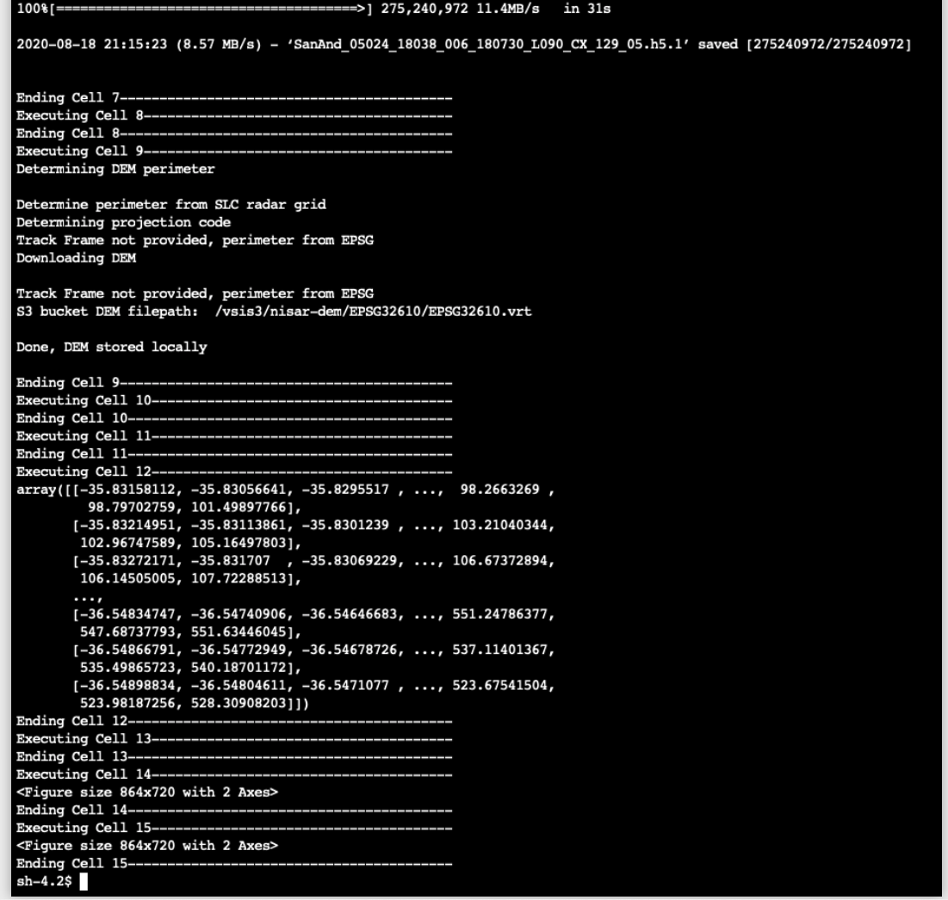

The first argument is the input notebook (**04-NISAR_DEM_notebook.ipynb**). The second argument is the **output notebook** which will contain the contents as a result of the execution (the default is stdout). Subsequent arguments preceded with ‘-p’ indicate values for the input parameters (again, in this case, *url*).

Papermill reports on the progress in terms of the cell being executed and any log messages (since --log-output was specified on the command line). The most time consuming cell is #7 which downloads the input dataset and takes between 30 and 60 seconds.

Once papermill has completed processing the notebook, return to the browser tab containing the contents of the nisar-on-demand-use-cases directory. In it, you will see a new file; **04-NISAR_DEM_notebook_output.ipynb**. Click to open it in a new tab.

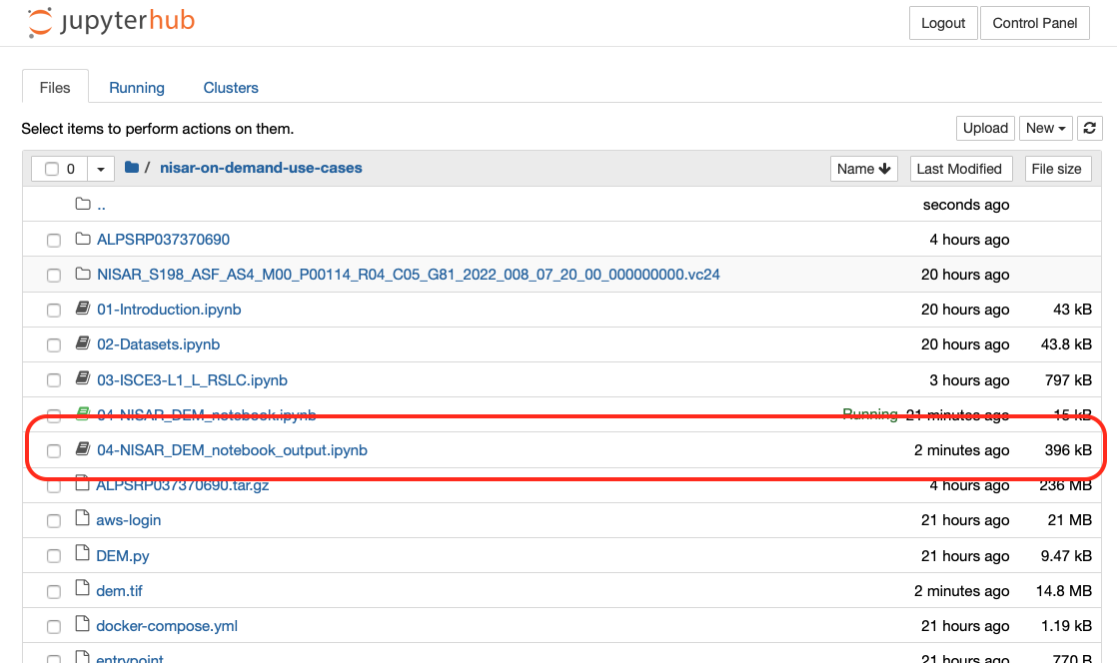

This new notebook will look exactly like the original but will include the execution output. The final two cells include images showing the elevation contours of the San Andreas region, as shown here.

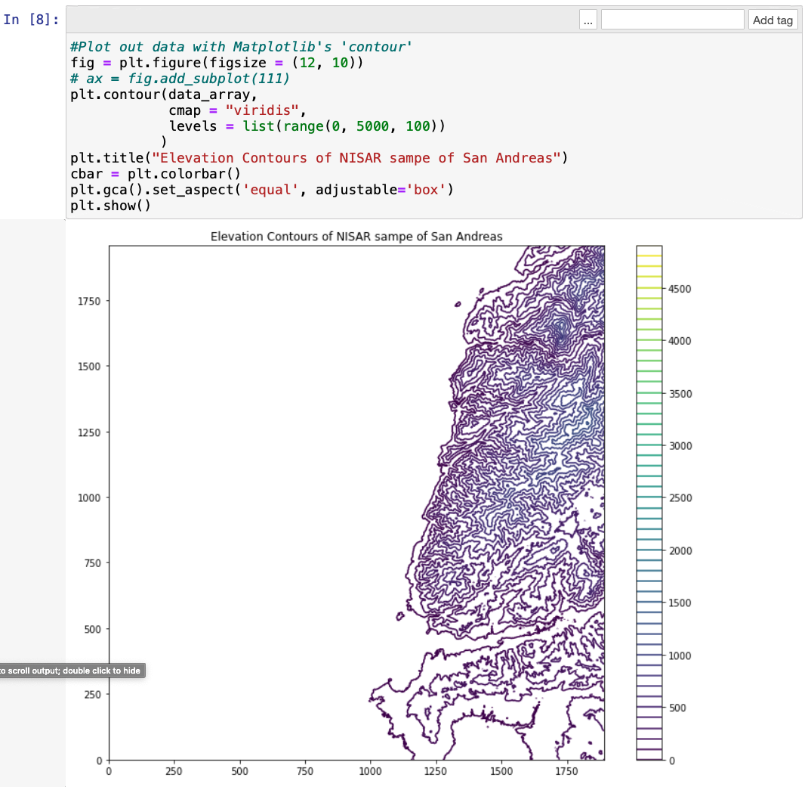

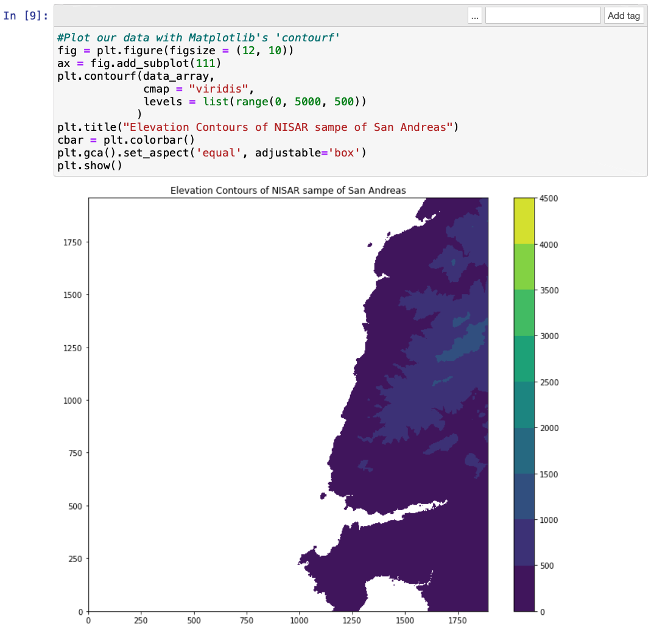

### Notebook #5 – Tunable Parameters

**Summary**: This notebook exercises the NISAR GCOV processor first to produce a standard L2_L_GCOV product using the default configuration parameters and second to produce a custom L2_L_GCOV product using customized configuration parameters. The input RSLC product will be identified using the *pele* API and the GCOV jobs will be submitted to the PCM cluster using the *otello* API, both of which are part of the PCM toolset. Finally, PLAnT will be used to visualize the results.

**Kernel:** plant

At this point it’s likely you’re getting the hang of working with notebooks and the core tools such as the *pele* API (we’d of course like to hear feedback if that isn’t the case). Given this, we will start paring down the notebook discussions (particularly with regards to screen shots) to key areas and distinctions.

**Step 0 – Initial setup**

Prior to running this notebook you should ensure that the *~jovyan/.netrc* file contains an entry for the *pele* entry point (aka “mozart ip”) that you registered for and set-up in 2.4.2 Notebook #1 - Introduction. You should also make sure your aws credentials are current, using the *aws-login* utility to do so.

**Step 1 – Initialize output directory, perform imports**

This step also prints the version of PLAnT that is being used.

**Step 2 – PCM initializations**

Here you enter the IP address of the PCM entry point which is used to establish connections to the PCM cluster. The variable *m* represents the connection for the *otello* API which provides job management. The variable *pr* represents the connection for the *pele* API which provides querying capability for available datasets.

**Step 3 & 4 – Identify the GCOV processor**

These steps first obtain and initialize a handle to the GCOV job, then displays the tunable and dataset parameters available for it. The primary objective of this notebook is to demonstrate how the tunable parameters can be set to produce a custom output product.

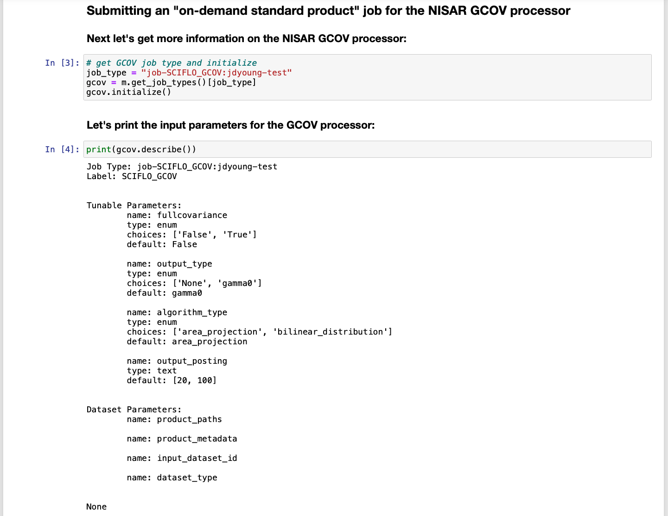

**Steps 5 & 6 – Obtain information on input RSLC dataset**

For simplicity, this notebook utilizes a hard-coded input RSLC dataset (see 2.4.3 Notebook #2 – Datasets and 2.4.4 Notebook #2.1 – Datasets w/ geospatial and time filtered queries for discussions on submitting *pele* queries to identify datasets. These steps obtain and print the product metadata for this dataset.

**Step 7 – Set the input dataset**

This cell specifies the input dataset to the GCOV job object.



**Step 8 – Display current parameter values**

The job’s *get_input_params()* method is called to obtain the list of (at this point, default) configured job parameters.

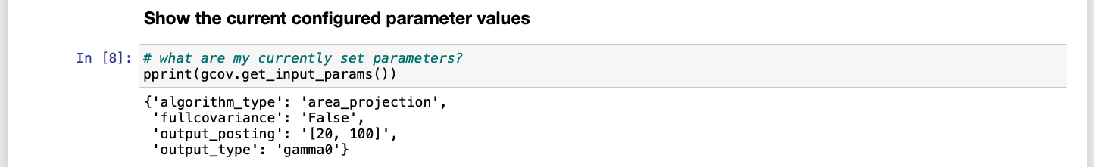

**Step 9 – Submit the job**

Now the job is submitted, specifying a tag to help identify it. The tag is optional. Note that job submission is asynchronous and the method will return as soon as the server confirms receipt.



**Step 10 – Wait for job completion**

The *wait_for_completion()* method is called using the handle for the submitted job (as returned by *submit_job()* in the previous cell) which blocks until the job completes or terminates due to an error. A message is displayed every 30 seconds reporting on the status of the job (from *job-queued* to *job-running* to *job-completed*).

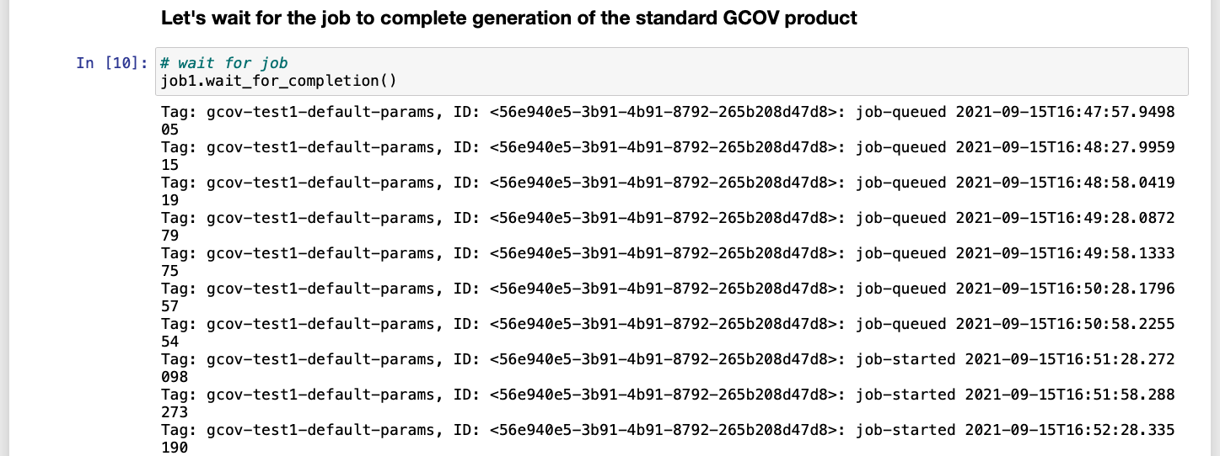

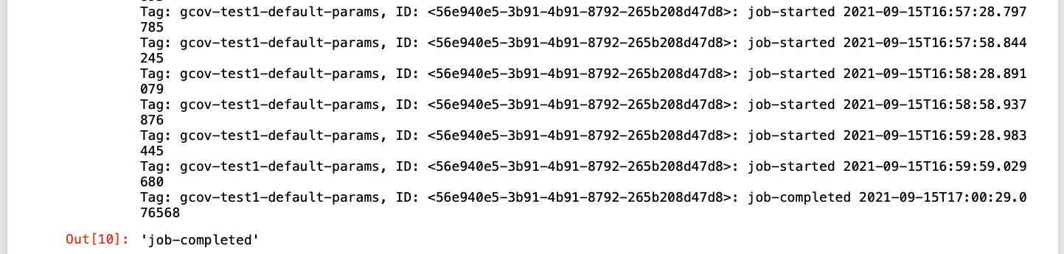

**Step 11 – Examine the result dataset**

Once completed, the submitted job handle will contain the result dataset(s) metadata which can be extracted using the *get_generated_products()* method.

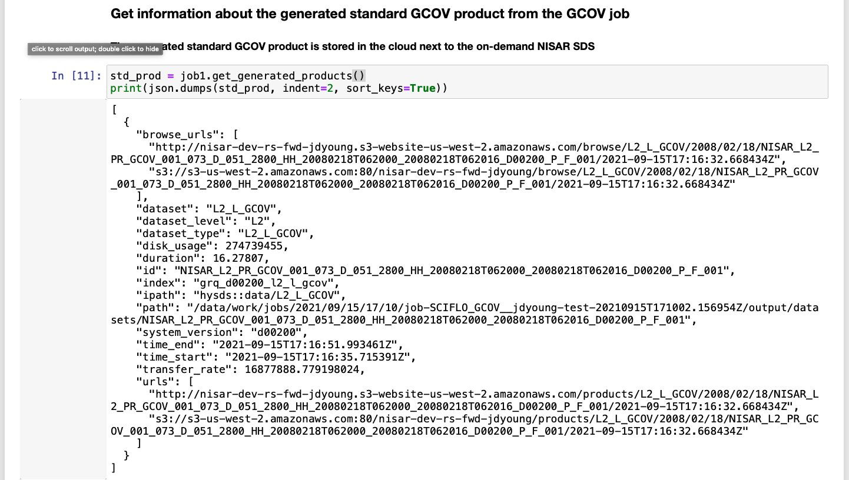

Steps 12 to 15 – Download and visualize the results

The next few steps download the result dataset (to the notebook environment, not your local machine) and uses PLAnT to perform a few visualizations.

Steps 16 and onward – Re-running the job w/ custom parameters

The first run used only default values for the 4 tunable parameters (see step 8 above) to produce a ‘standard’ GCOV product. In this second run, 3 of the 4 parameters will be changed to produce a custom GCOV product by calling the processor’s *prompt_input_params()* method and providing the specific parameter values in step 16.

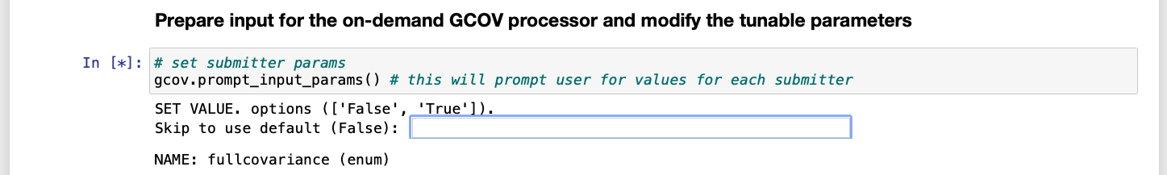

The remaining steps are the same as in the first run, so we will not repeat the discussion. You will notice that the output plots should vary somewhat between them.

### ARIAtools

**Summary:** This notebook exercises the ARIA-tools package and was constructed from unit tests found in the *config.yml* found in the ARIA-tools repository and the accompanying documentation. Links to both sources are found in the notebook introduction.

As discussed in section 2.3.1 Notebook kernels, this notebook demonstrates how code can be executed in a different conda environment other than that currently active in the notebook kernel.

**Kernel:** mintpy

Step 0 – Initial setup

This notebook will download data from the ASF DAAC, so make sure your .netrc file contains an entry for earthdata with your credentials:

machine urs.earthdata.nasa.gov login <earthdata_user> password <earthdata_password>

Also be sure your aws-credentials are valid and current.

**Step 1 – Function definitions**

This cell peforms necessary imports, the standard directory initializations and defines a *plot_layer()* function. (Screenshot omitted).

**Step 2 - ariaDownload**

This step sets up some additional output subdirectories then demonstrates how to submit product queries to the ASF DAAC using the *ariaDownload* utility.

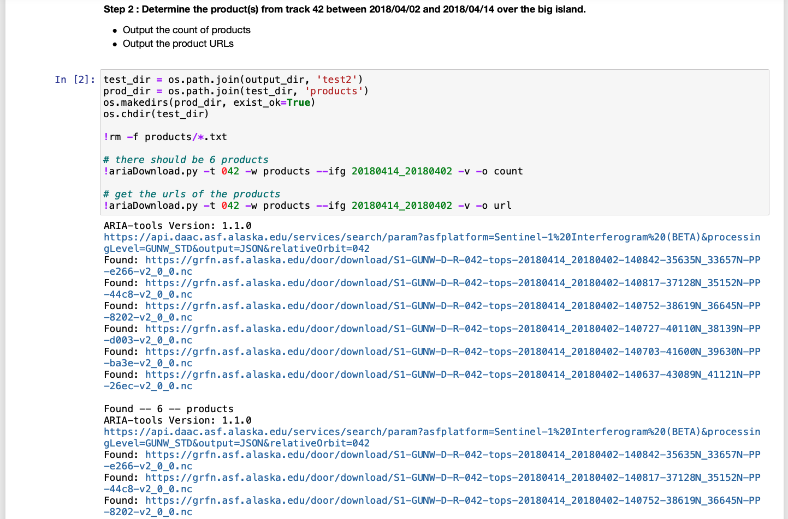

**Step 3 – Download one of the product files**

A simple *wget* is issued to download one of the product files identified in the previous step. Note that if you’ve run the notebook before, you will receive a message that the file already exists and is not (re)downloaded.

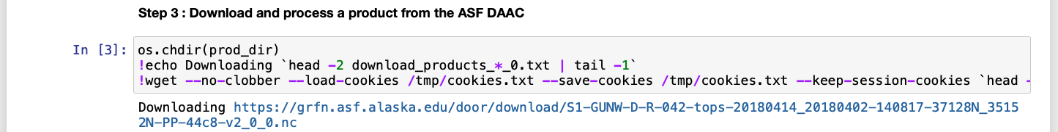

**Step 4 – Extract the bounding box, then the DEM using a different conda environment**

Here is where the magic happens. First the bounding box of the feature identified by the dataset we downloaded above. Then we use *conda run -n isce* to run the *DEM.py* code in the isce conda environment. Again, this does not permit sharing of variables with the mintpy conda environment, but it does allow access to ISCE3 and its dependencies (at the cost of immediate access to those in mintpy). The DEM takes a couple of minutes to download.

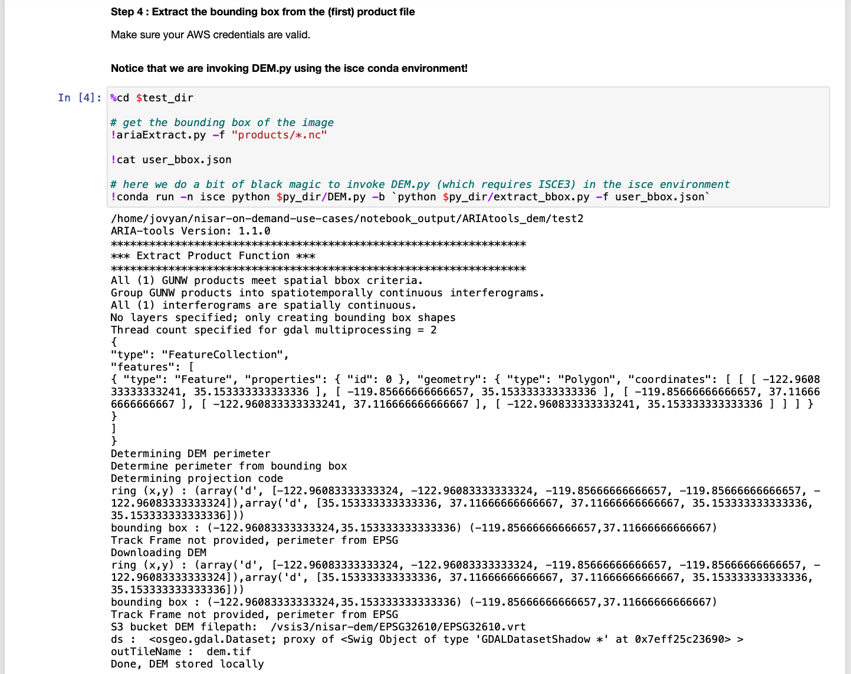

**Step 5 – Data extractions**

This step uses *ariaExtract* to extract various products from the dataset; azimuth angle, amplitude, coherence and the unwrapped phase layer.

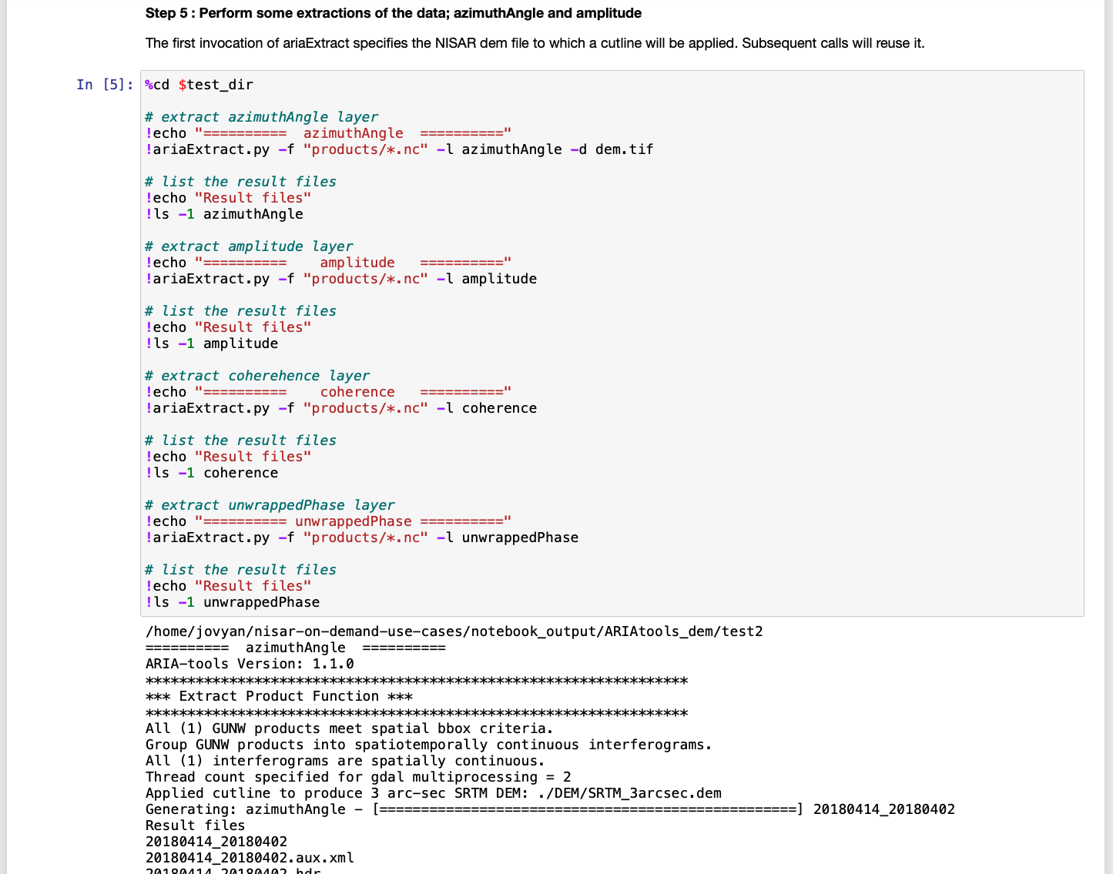

**Steps 6 to 10 – Plot the extractions**

These steps visualize the extractions computed above using the *plot_layer()* function defined at the beginning of the notebook. You can ignore (for now) the matplotlib deprecation warning. Here is the amplitude plot:

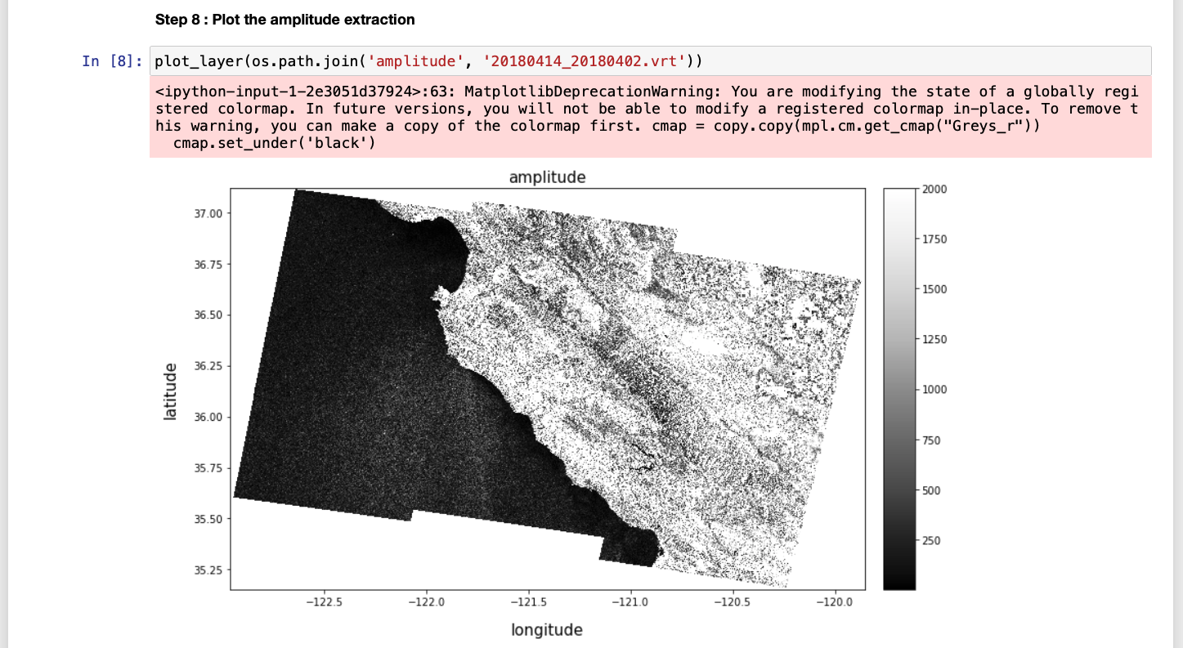

### topsStacks – Sentinal-1 TOPS stack processor

**Summary:** Fattahi, Agram and Simons (2016), *A Network-Based Enhanced Spectral Diversity Approach for TOPS Time-Series Analysis, IEEE Transactions on Geoscience and Remote Sensing* (DOI: [10.1109/TGRS.2016.2614925](https://ieeexplore.ieee.org/abstract/document/7637021)) describes a network-based enhanced spectral diversity approach to reduce impact of temporal decorrelation on co-registration for multitemporal analysis of SAR images acquired in TOPS mode. These stack processing algorithms are exercised in this example notebook, a slightly modified collection of steps taken from

<https://github.com/isce-framework/isce2/blob/main/contrib/stack/topsStack/README.md>

Read this section for an example of ISCE2 processing.

NOTE: There is a more `actively developed example of topsStacks processing found here:

https://github.com/aria-jpl/topsstack-hamsar

**Kernel:** isce

**Step 0 – Initial setup**

Prior to executing this notebook you will need to 1) add your Earthdata login information to the .netrc file and 2) establish valid AWS credentials. To do these, open a terminal (which we did before on page ) and perform the following:

First, edit the ~/.netrc file, adding the line:

machine urs.earthdata.nasa.gov login **earthdata_user** password **earthdata_password**

and replacing the *earthdata_user* and *earthdata_password* with your Earthdata login information and saving the file.

Second, run the *aws-login* as you did on page .

**Steps 1 to 6 - Function definitions**

The first 6 code cells perform necessary imports and define supporting functions. Since they produce no relevant output, their contents are largely omitted here. There are however a couple of note:

- The third cell is tagged with the “parameters” annotation which as you recall from “2.2.5 Notebook #4 - DEM Notebook through Papermill” enables the variables declared in that cell to serve as inputs when the notebook is executed as stand-alone through Papermill:

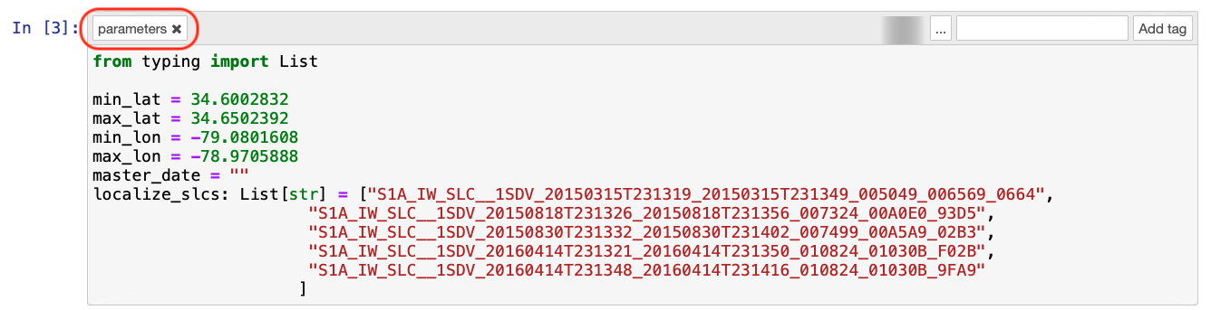

**Step 7 – Bounding Box**

This step extracts the lat/lon coordinates of the bounding box of interest from the context established in the parameters-annotated cell.

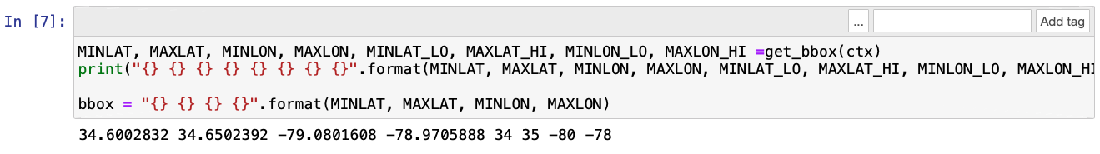

**Step 8 – Downloading the SLC files**

The SLCs identified in the parameters cell are downloaded. Note that these files are significant in size (around 5GB each) which will collectively require a significant amount of time to download (expect around 2 minutes per SLC).

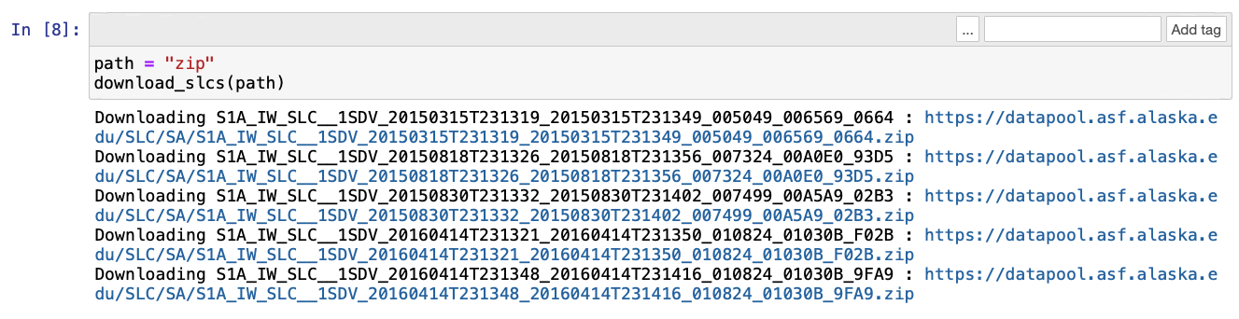

**Step 9 – Download orbit files**

The orbit files identified based on the set of SLCs downloaded in the previous step. They are placed in the *orbits* subdirectory.

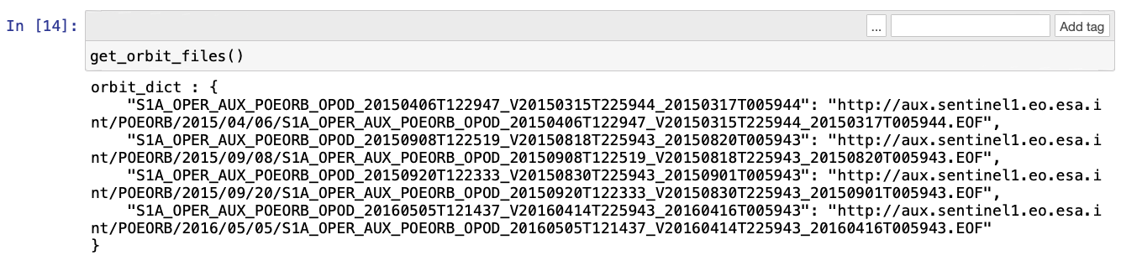

**Step 10 – Download DEM data and generate DEM file**

Similarly to the orbit files, the DEM information to retain is computed based on the bounding box.

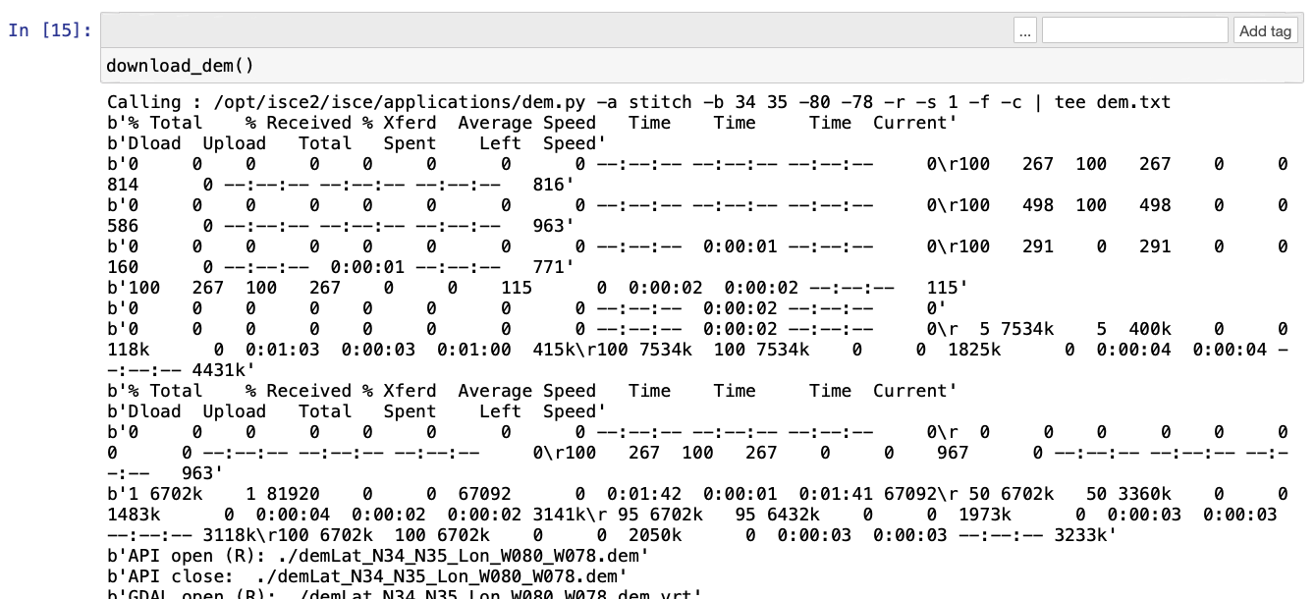

(output truncated for brevity)

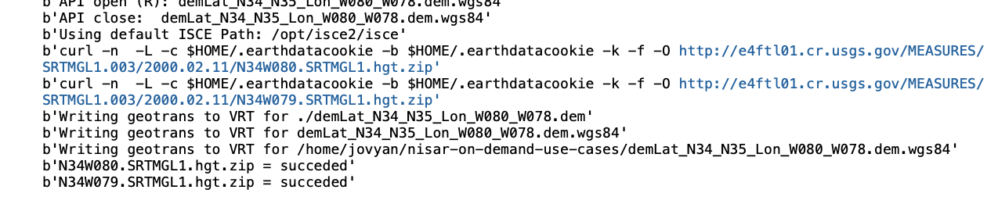

**Step 11 – Fix paths in dem file**

This step invokes the isce2 application fixImageXML.py in order to fill in the complete path to the files referenced in the dem file.

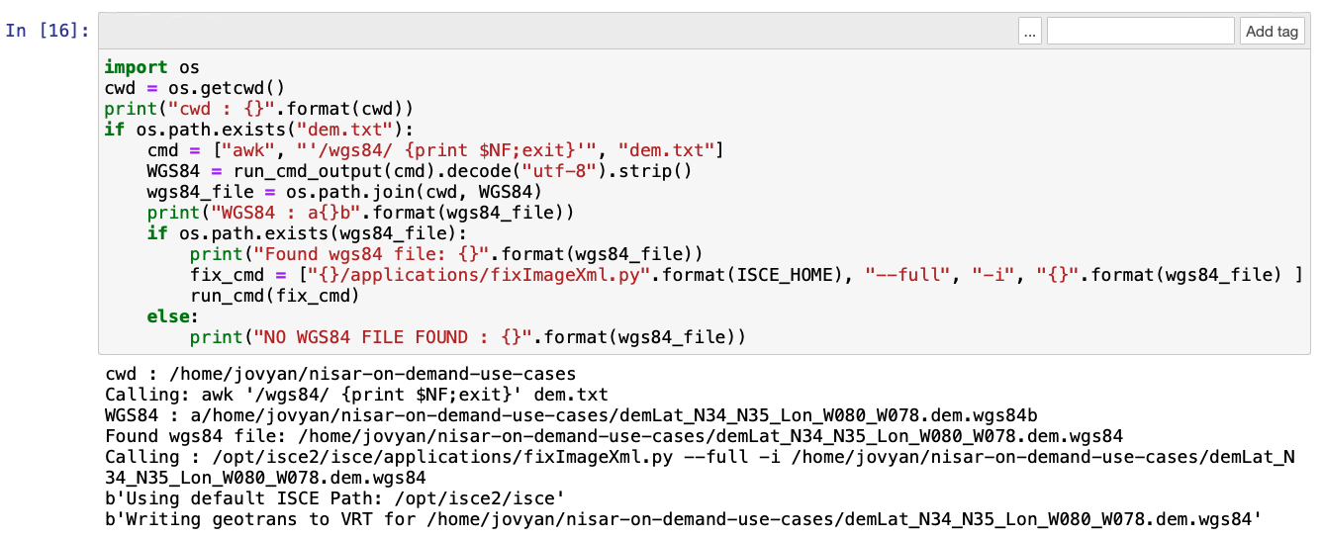

**Step 12 – Download the auxiliary calibration file**

The auxiliary calibration (aka AUX_CAL) file is used to compensate the range phase offset of SAFE products acquired prior to March 2015. The text cell above this step shows up to download the file from the on-demand S3 bucket.

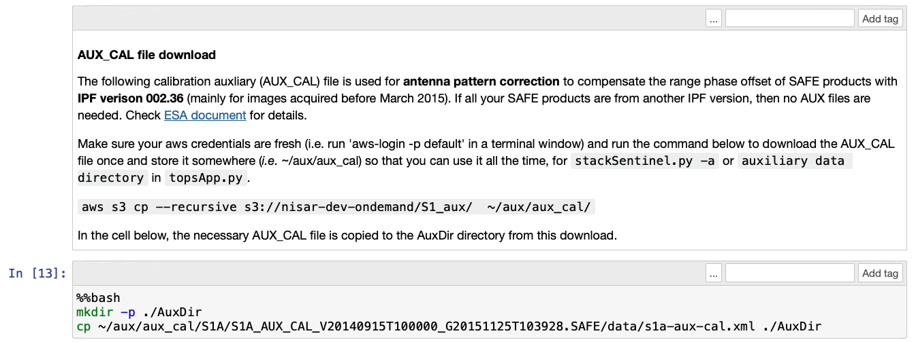

Step 12 – A bit of cleanup

This cell ensures that the *run_files* and *coreg_secondarys* directories are removed and moved aside, respectively. Presence of either directory will block processing in the following steps.

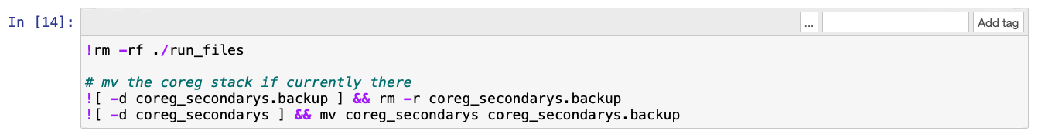

**Step 13 – Generate run files**

*stackSentinal.py* is now invoked to generate the stack processing workflow as a set of run files which are not coincidentally placed in the *run_files* subdirectory. If this step needs to be re-run, you must first remove that subdirectory or *stackSentinal.py* will error out. The contents of the run files are contingent on the input dataset (i.e. bounding box, SLCs and orbits).

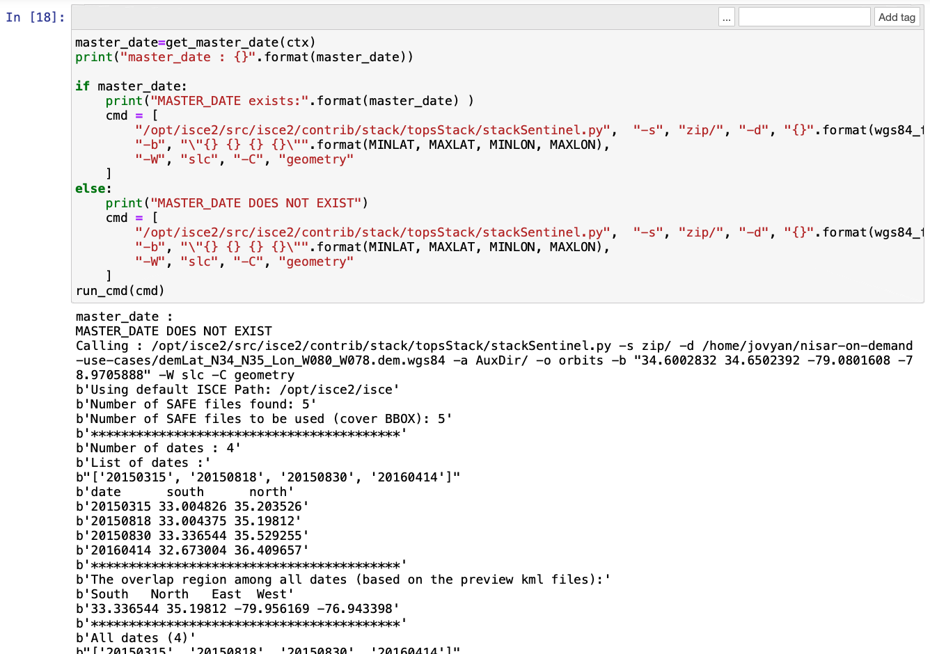

(output truncated for brevity)

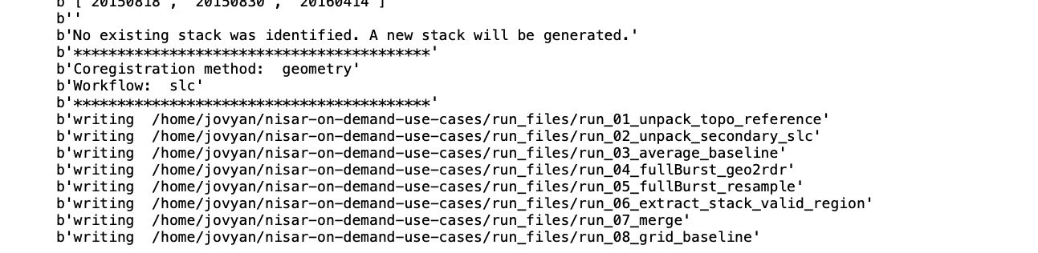

**Step 14 – Add noise cancellation run file**

An intermediate run file must be manually added between run files 2 and 3 in order to perform radiometric and thermal noise cancellation. This step injects this run file, executing against each SLC file.

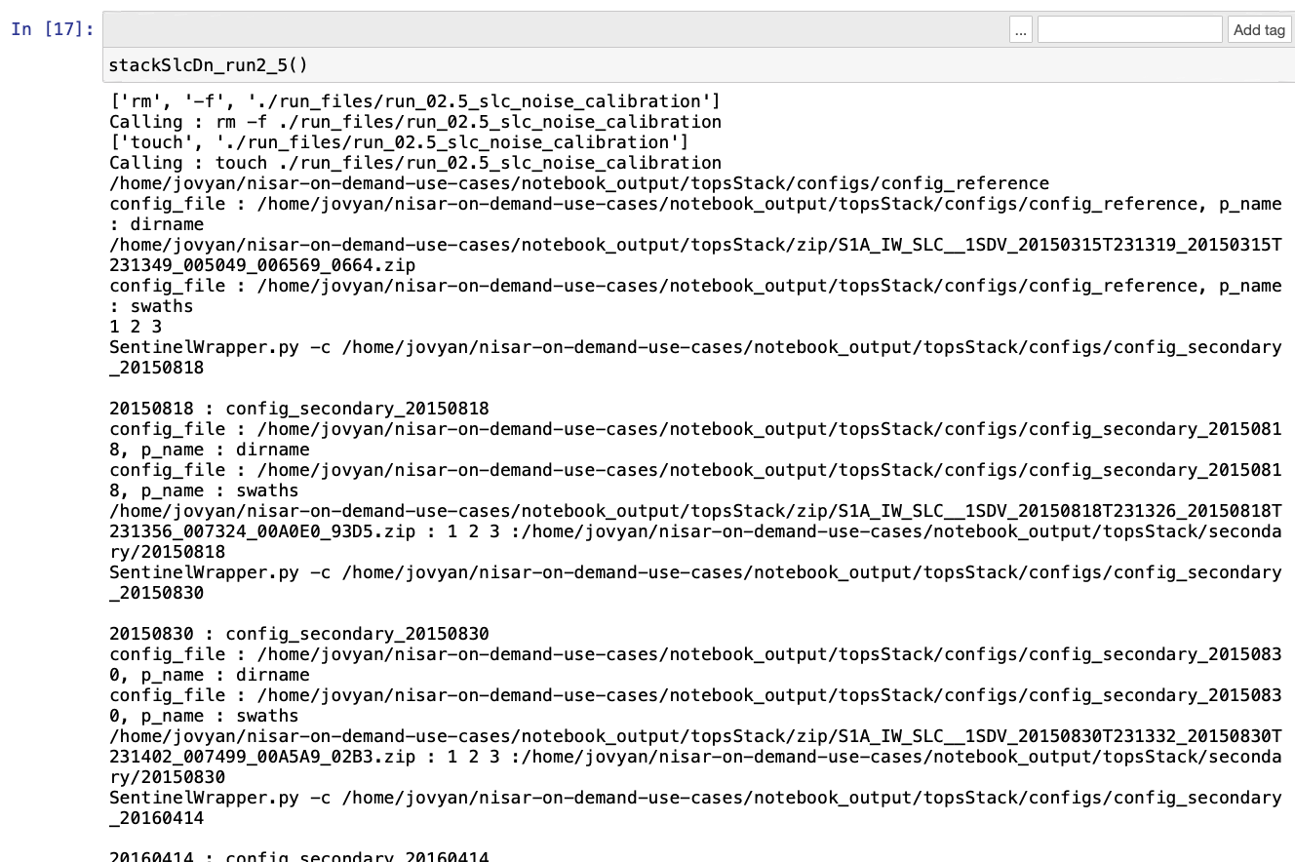

Most of the run files require a few minutes to complete execution.

There are a couple of Warnings/Errors that may appear which neither affect processing nor its results. The following can be safely ignored:

sh: /dev/tty: No such device or address

and

/opt/isce2/src/isce2/contrib/stack/topsStack/SentinelWrapper.py:113:

SyntaxWarning: "is" with a literal. Did you mean "=="?

if iString is '':

**Step 15 – Run File 01: Unpack the SLCs**

The initial run file unpacks the SLC files using ISCE readers, also unpackaging the antenna elevation pattern correction file if necessary. This run file also produces the reference geometry files that are consumed downstream.

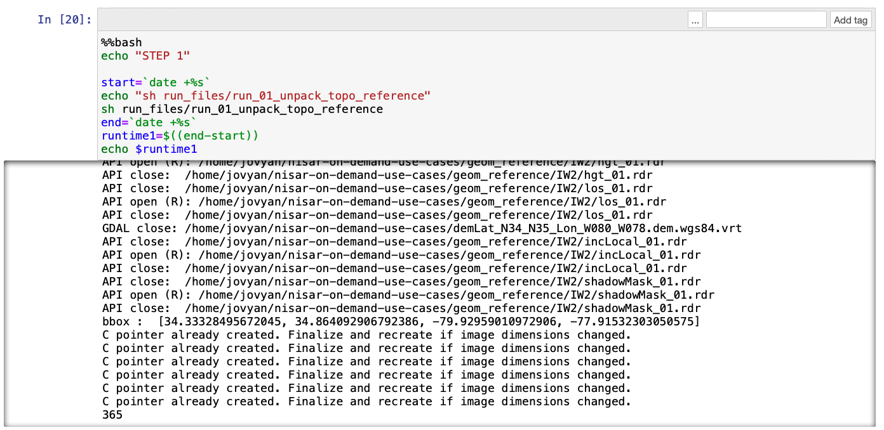

**Step 16 – Run File 02: Unpack Secondary SLCs**

In a manner similar to the SLCs in Run File 01 above, this run file unpacks the secondary SLCs from each of the input SLC zip files.

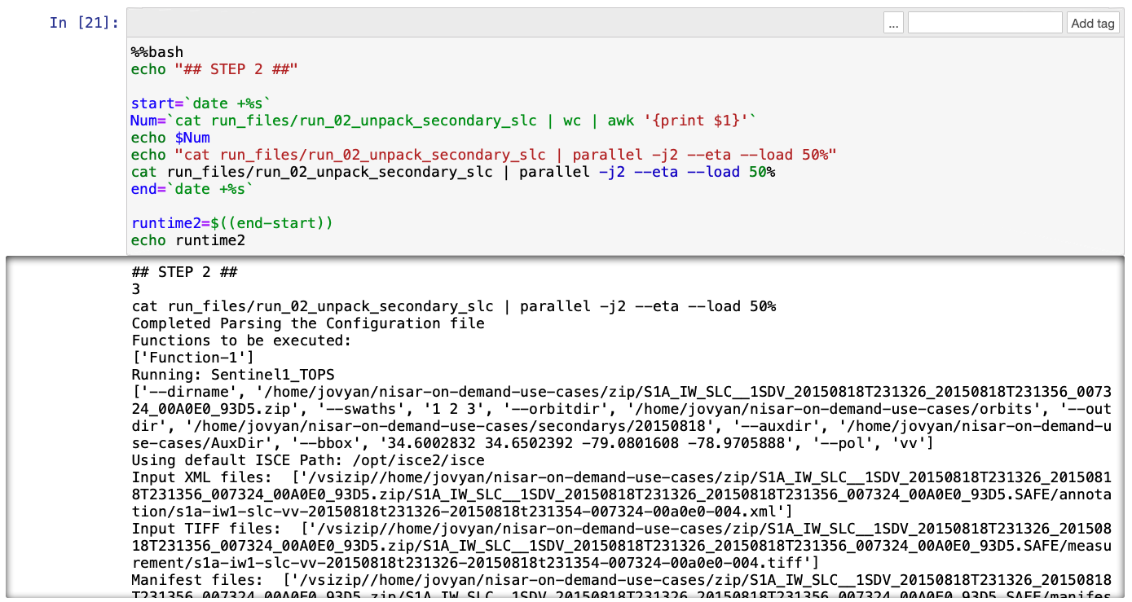

**Step 17 – Run File 02.5: SLC Noise Cancellation**

This run file, which was manually introduced in step 14, runs radiometric and thermal noise calibration using vh-pol data against the SLCs.

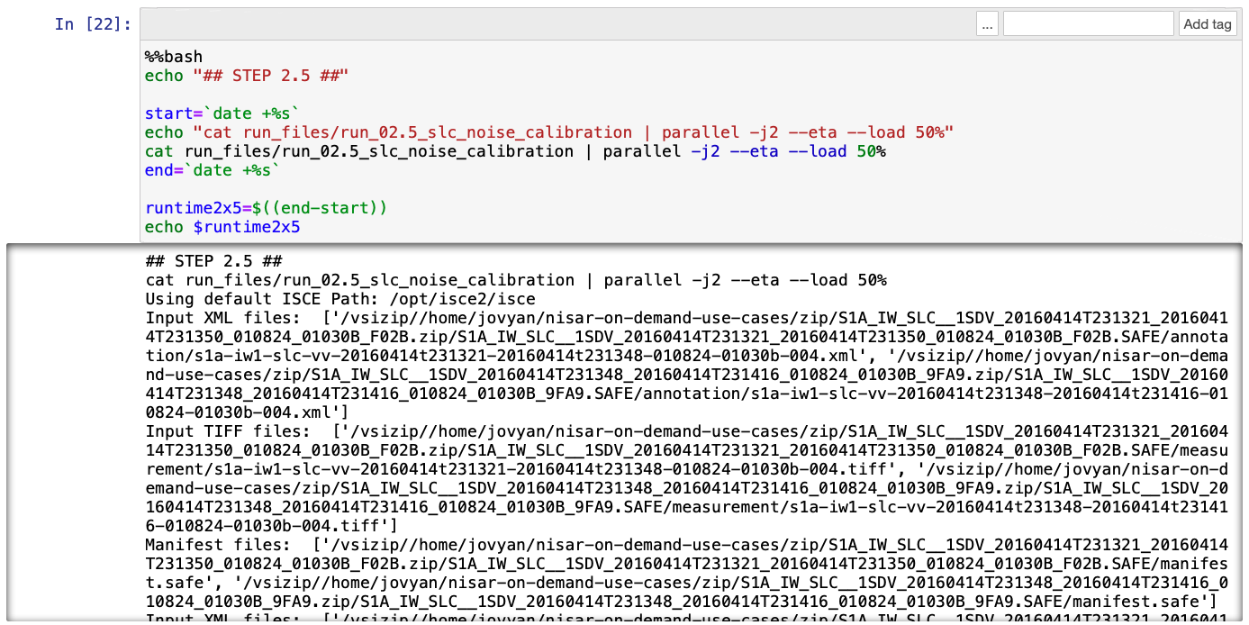

**Step 18 – Run File 3: Compute Average Baseline**

This run file computes the average baseline for the stack, as an approximation that can be used for plotting purposes. Of all the run files, this requires the least amount of time and should complete in sub-seconds.

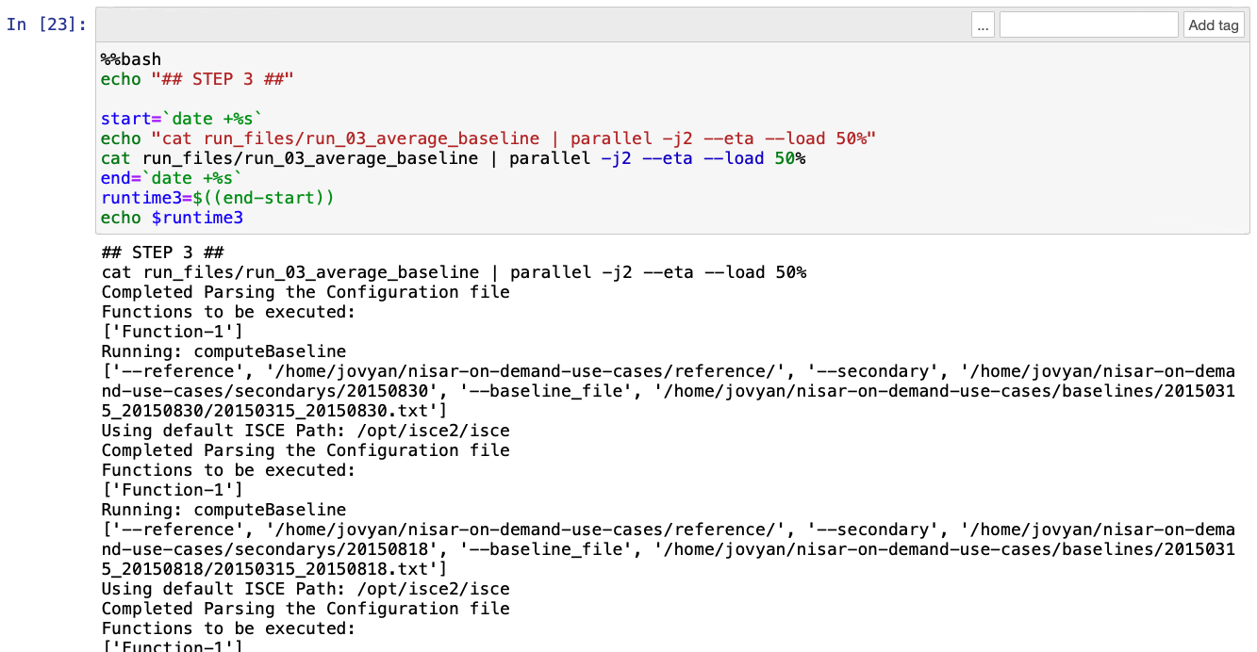

(output truncated for brevity)

**Step 19 – Run File 4: Full Burst geo2rdr**

This run file estimates geometrical offsets between secondary burst overlaps and the stack reference burst overlaps. The secondaries are then resampled to the stack reference burst overlaps.

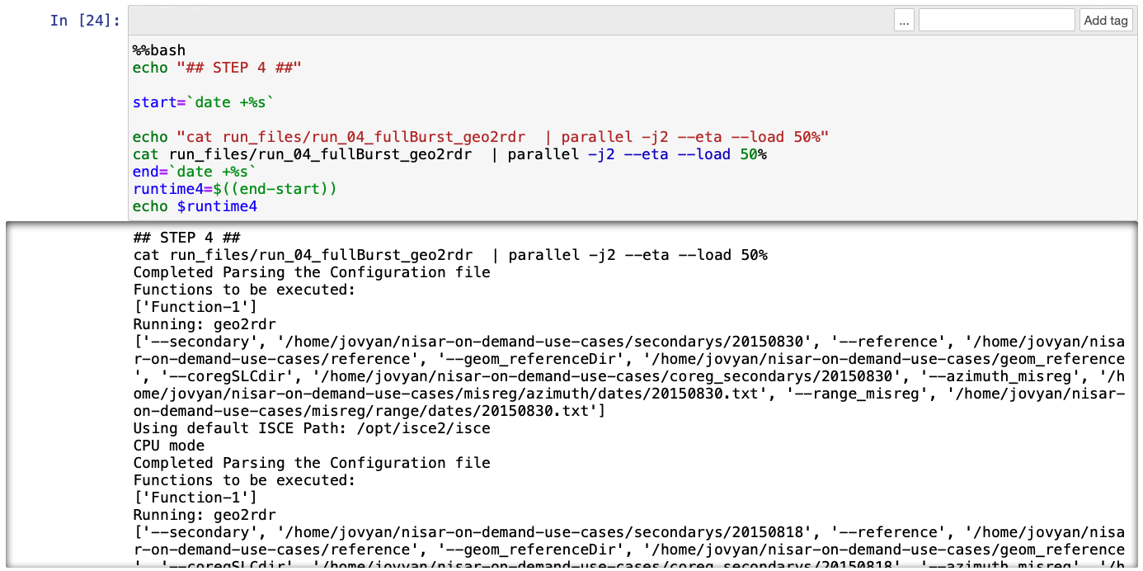

**Step 20 – Run File 5: Full Burst resample**

Using orbit and DEM data, this run file computes geometrical offsets among all secondary SLCs and the stack reference. These offsets, with the misregistration time series are used for precise coregistration of each burst SLC.

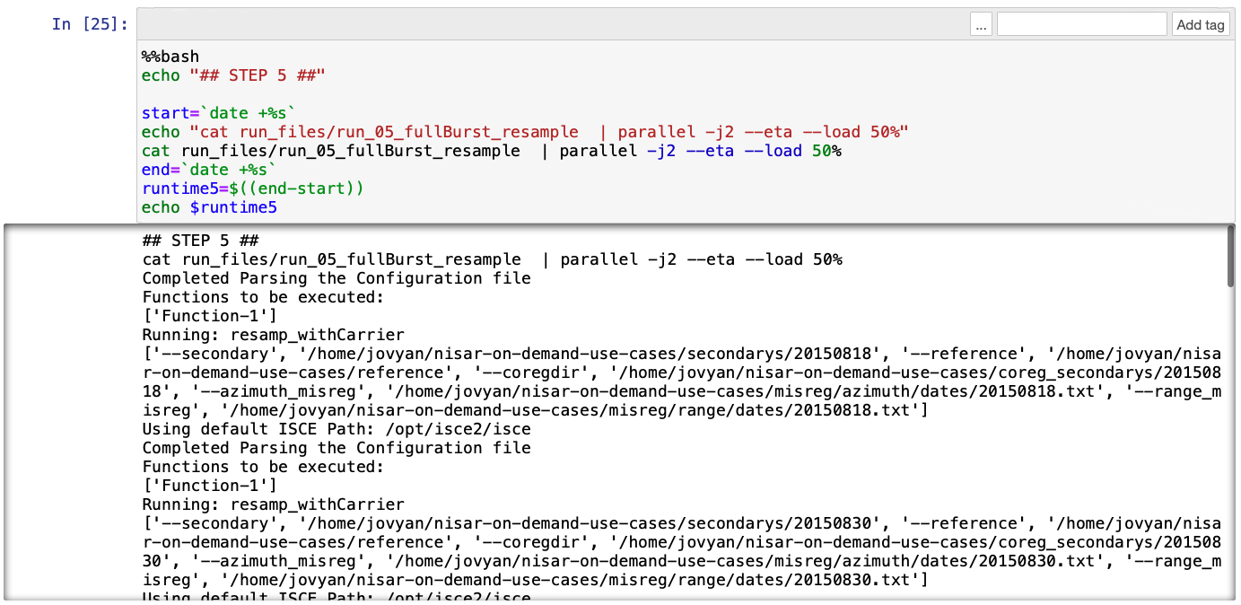

**Step 21 – Run File 6: Extract Valid Region**

This run file extracts the valid region between burst SLCs at the overlap area of the bursts. This region changes slightly changes for different acquisitions and must be retained for merging the bursts to eliminate invalid data.

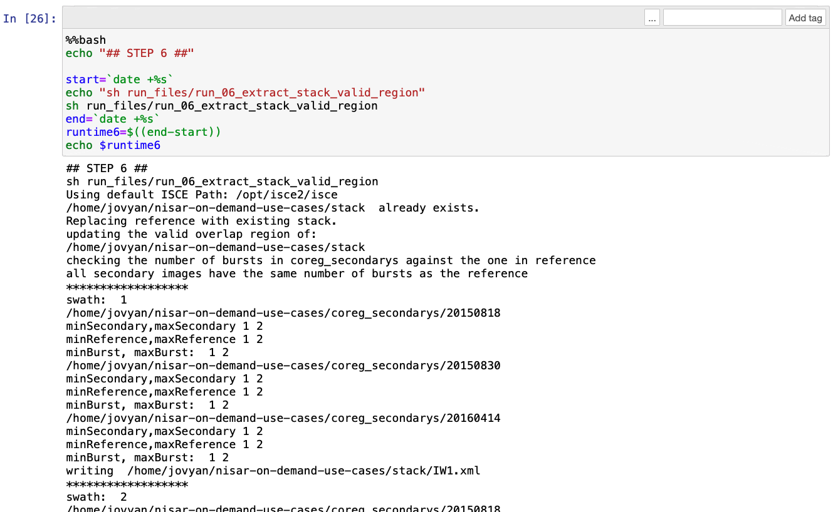

**Step 22 – Run File 7: Merge Reference Secondary SLCs**

This run file merges all bursts for the reference and coregistered SLCs. Geometry files are also merged.

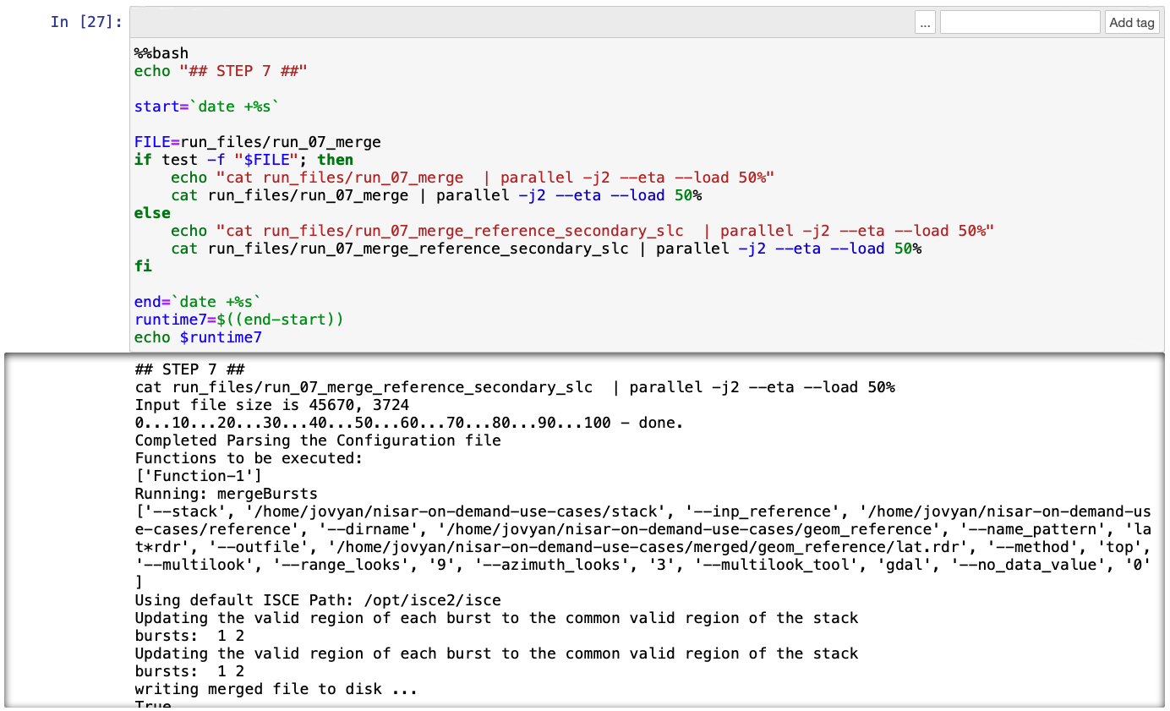

**Step 23 – Generate datasets**

The final step ‘packages’ up the results into a single sub-directory named as *coregistered_slcs-<start_date>-<end_date>* and generates json files describing the dataset (e.g. the polygon coordinates of the bounding box) and associated metadata (e.g. included SLCs).

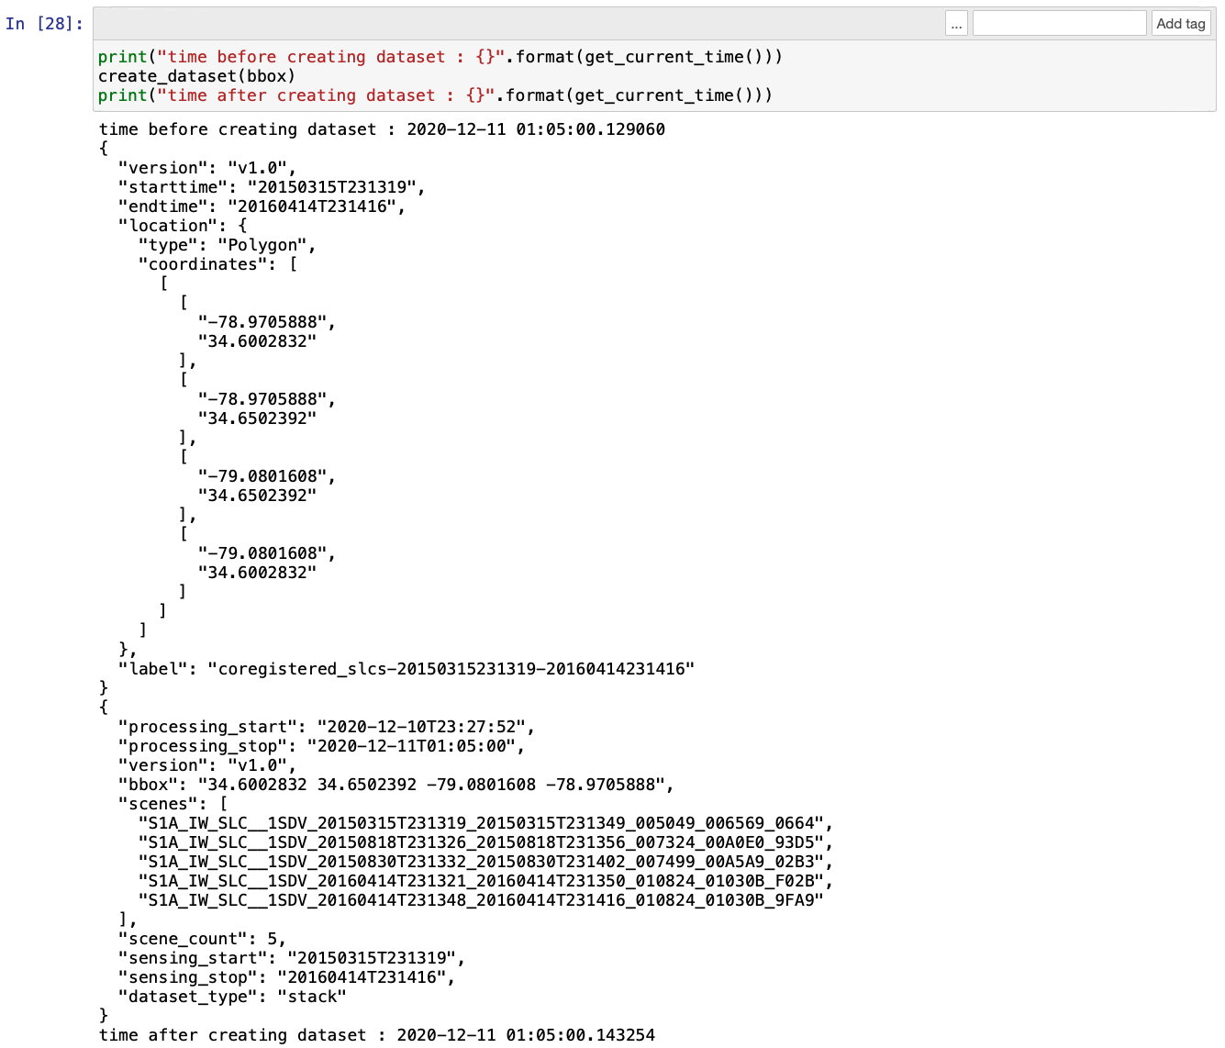

### Cleaning up

**Summary:** Having gone through a few of the example notebooks provided, this section presents the best-practices for shutting down running notebooks (kernels) and the Jupyter Server itself. Reading this section is recommended for those unfamiliar with the Jupyter Notebook lifecycles.

Congratulations on completing this exercise. At this point, you likely have at least a couple of running notebook processes and one or more terminals (simply closing the associated browser tab does not terminate the underlying process), not to mention the overarching Jupyter server. Depending on the Jupyterhub configuration, the server may have a lifetime restriction after which it is automatically shut down. However, it is good economic practice to shut things down prior to walking away for any significant amount of time (e.g. for the day).

Changing server instance types also requires you to first stop your existing server instance. You may then start a server instance of a different type.

What remains persistent between server sessions is straightforward. Anything within the home directory will be retained and be available on the restart of the server and is shared between different instance types. Any package installations (e.g. pip, yum, etc.) performed after the server start - that is, anything not part of the original server image - is lost and must be redone.

**Saving notebooks**

Notebooks are autosaved, so *most* content is retained. The autosave is periodic however (in terms of a couple of minutes depending on actions taken), so there is a chance that some loss may occur in an inadvertent shutdown. The current save state is shown at the top of the page:

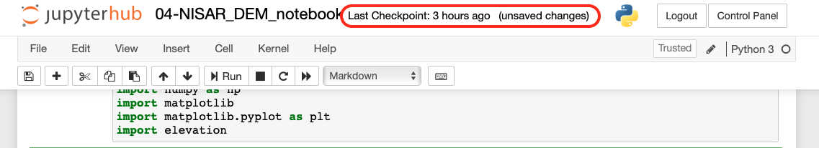

A save can be explicitly made by using File -> Save and Checkpoint:

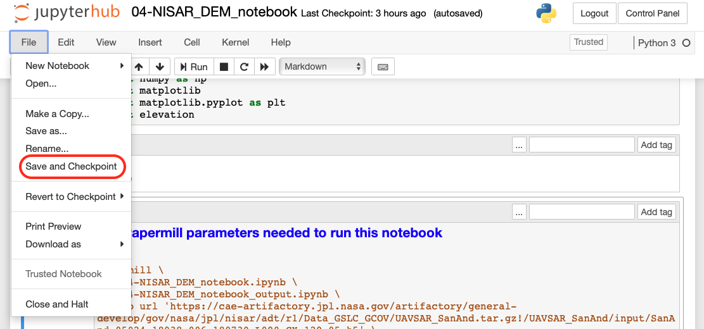

**Processes**

A server shutdown implicitly terminates any running processes so it is prudent to verify what is running prior to the shutdown to ensure nothing critical remains running.

To view the processes that are currently running, click on the Running tab of the browser tab containing the directory contents:

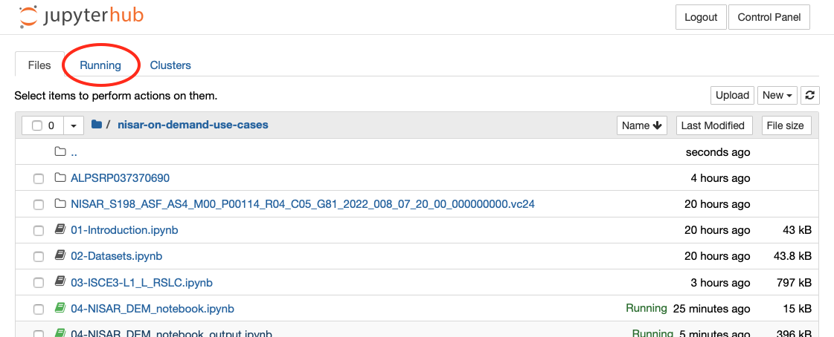

All running processes are listed, organized into terminals and notebooks:

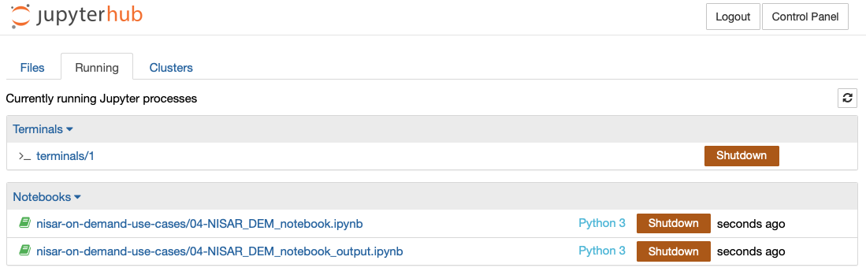

Individual processes can be terminated using the associated Shutdown button.

**Server shutdown**

To shutdown the server, click on the Control Panel button at the top right of the page:

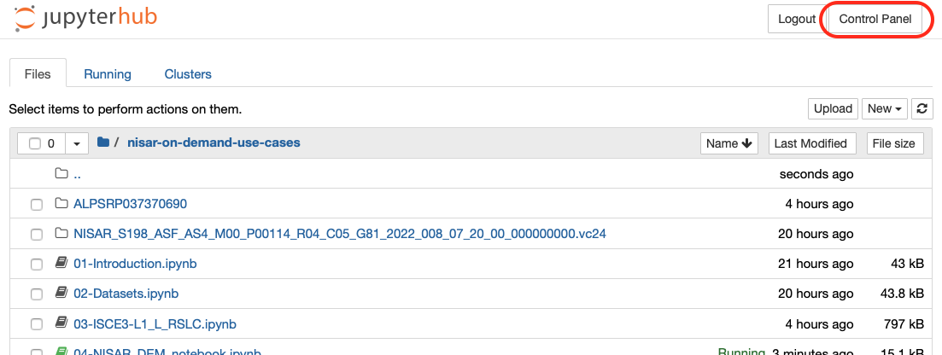

Which, if the server is running, will show a Stop My Server and My Server buttons:

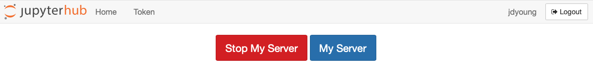

Clicking on **Stop My Server** will terminate it after a few seconds. Clicking on **My Server** will return to the directory contents page. Once the server is terminated, these buttons will be replaced with a **Start My Server** button which can be used to restart the server - exactly as if you had just logged in.

**Logout**

A Logout button appears on each tab opened through Jupyter interaction. This does not terminate the associated process but does terminate your ability to interact with it through that particular tab. To restore interactivity with the process, you can log back in or click on the process in the control panel to open it in a new tab.

### Additional Notebooks Available

It’s easy to see there are a few more notebooks included in the repository, each exercising a particular component of the full-stack NISAR Jupyter server environment. Beyond the particular science processing (which we clearly consider the most important aspect), there is nothing new to discuss in the context of Jupyter notebooks. Running through these is left as an exercise for you to perform at your leisure/whim.

Here is a brief summary of these notebooks:

* **ARIAtools.ipynb** – A collection of steps extracted from the test steps found in the ARIA-tools *config.yml* and the associated documentation. The repository can be found at: <https://github.com/aria-tools/ARIA-tools>.
* **maap-plant-demo_20181206.ipynb** – Taken from the PLAnT repository (<https://gitlab.com/plant/plant>) in the directory *notebook/MAAP/demo1*. As stated in the notebook, you will need to manually install the MAAP API.
* **smallbaselineApp.ipynb** – Taken from insarlab’s MintPy-tutorial repository (<https://github.com/insarlab/MintPy-tutorial>). As notebook-based tutorials go, this is an excellent example.
* **InSAR Time Series Analysis using MintPy and ARIA products** – Provided by Eric Fielding, this notebook is an example of how notebooks originally developed in the OpenSARLabs environment can run, largely without modification, in the NISAR environment. See section 2.4.12 Compatibility w/ notebooks from OpenSARLabs for more details.

There are two more notebooks in this directory; *create_topsApp_job.ipynb* and *submit_topsApp_job.ipynb*. These two are related to the execution of the *topsApp.ipynb* notebook (found in the *notebook_pges* directory) at scale. This will be discussed further in the next section.

### Compatibility of notebooks from OpenSARLabs

The example notebook which was taken from the OpenSARLabs (OSL) environment demonstrates that there is at least some compatibility between it and NISAR’s On-Demand environment. The degrees of compatibility are described in the following:

* Minimal to no changes required – notebooks that:
  + employ ISCE2, MintPy, ARIATools and PLAnT
  + do not employ OSL-specific APIs
* Installation of additional packages - notebooks that employ:
  + any open-source packages not listed in the above
  + OSL-specific APIs such as asf_hyp3
    - Note that in this case, the locality of the data and processing remains on OSL
* Not supported – notebooks that employ licensed software, e.g. GAMMA (www.gamma-rs.ch)

## Executing Notebooks at Scale – A Simple Example

**Summary**: This section goes through the process of running notebooks at scale as SDS PGEs, building upon Section 2.3.5 Notebook #4 - DEM Notebook through Papermill which enables notebooks to be executed stand-alone. Read this if you intend to run notebooks as PGEs and are unfamiliar with the *notebook-pge-wrapper* utility and the *otello* job management API.

In ADE contexts the ultimate goal is to be able to execute the algorithms at scale within the SDS frequently with custom input parameters. The NISAR PCM team has provided a simple yet effective set of tools and APIs which bridge the functional gap between executing notebooks in a Jupyter server with small datasets and their execution within a highly scalable SDS using much larger datasets. In this section, we’ll walk through the process by which this is performed using an example notebook (this notebook is kept extremely simple so as not to muddle the primary intent).

### Prerequisites

In order to run through this example, you will need a running PCM HySDS cluster with the following characteristics:

* Based on HySDS v4.0.0-rc.5 or later
* The mozart instance must be running the develop branch of the mozart API
* Configured to access the PCM Jenkins instance at: <https://nisar-pcm-ci.jpl.nasa.gov/>
* Access to a git-based version-control system (typically github.jpl.nasa.gov or github.com) in which you have repository create and write privileges

### notebook-pge-wrapper: Project Initialization

In this section we will discuss the initialization step for creating SDS executable notebooks. For subseq uent steps we will utilize an existing project so the directory/files created in this step will be considered throw-away.

The *notebook-pge-wrapper* utility is a key component of the PCM-provided tools and APIs which enable notebook execution at scale. The initial step is initializing a project and its directory using the following command in a Jupyter terminal window:

notebook-pge-wrapper create <project_name>

Where <*project_name*> is (not surprisingly) the name of the project to be created. The result is the creation of a directory of the same name which contains:

* README.md – a boilerplate README which provides information on how to use the utility.
* notebook_pges – a directory in which the notebooks to be enable are placed.
* docker – a directory in which will contain the generated SDS job files.
* docker/Dockerfile – a boilerplate Dockerfile which the SDS uses to build the job image(s).

Note that this step is *partially* destructive in that pre-existing *README.md* or *docker/Dockerfile* files will be over-written. Other files/directories that exist are not removed.

Now that you have seen the initialization first hand, you may remove the <*project_name*> directory and its contents as the remainder of this discussion will utlize and already-initialized project.

### Creating the Project Repository

As noted in the previous section, we will now switch to an existing project that contains a very simple notebook (*hello_world.ipynb*) that we will ultimately execute within the SDS. The build and execution process will be driven by two supporting notebooks that are also included. Because the build process involves change commits (by you) and cloning (by the build system) through a shared repository, you will need to create your own repository as a copy and available for checkout with a distinct URI. These steps should be executed within a Jupyter terminal in the ~jovyan directory.

First, down the original project by cloning the *develop* branch of the source repository:

git clone --single-branch -b develop https://github.com/jimmie/hello_world.git

You will then need to push this to a repository of your own. First, disconnect the local repository from the current origin (i.e. *github.com/jimmie/hello_world*):

git remote rm origin

Using a new browser window, navigate to the home of your personal github workspace, for example: *https://github.jpl.nasa.gov/jdyoung* or *https://github.com/jimmie*. Click the ‘+’ at the far right of the top nav bar and select “New repository” from the drop down that appears.

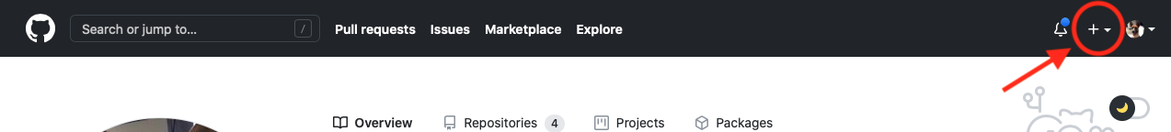

The Create a new repository form comes up. For Repository name, enter ‘hello_world’ (remaining consistent will make it easier for the sake of this example), select ‘Public’ for access (this will also simplify things) and leave all other checkboxes unchecked. Click the “Create repository” button at the bottom of the form.

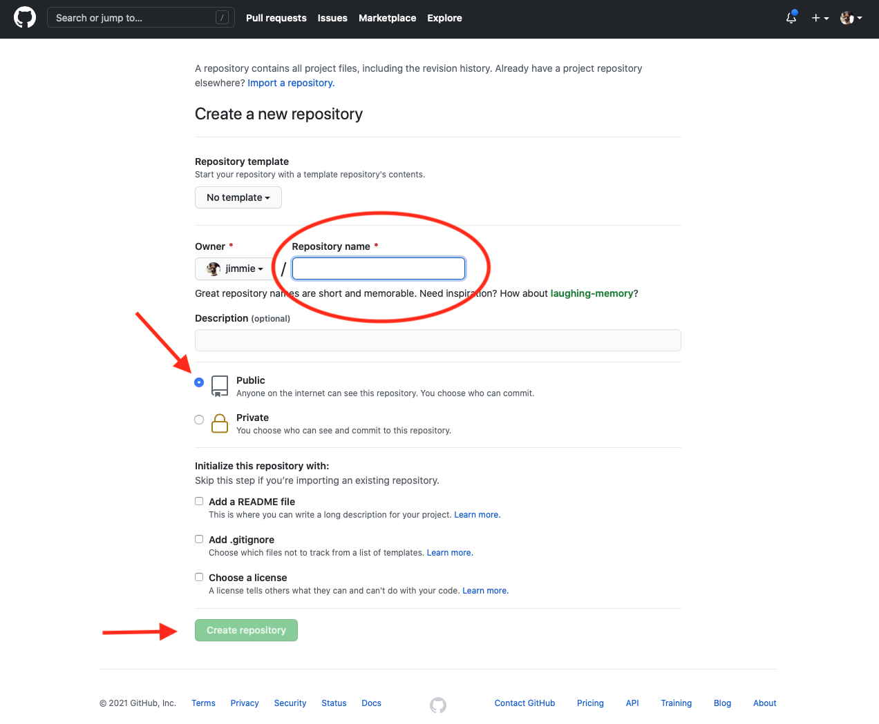

You are now done with that browser window and may close it.

Returning to the Jupyter terminal, associate the local repository with the remote you just created:

git remote add origin <repository URL>

where <*repository URL*> points to the newly created repository (e.g. [*https://github.com/jimmie/hello_world*](https://github.com/jimmie/hello_world)). Lastly, associate the current branch (i.e. *develop*) with the remote:

git push –set-upstream origin develop

To verify that everything went well, enter:

git status

The following should appear:

On branch develop

Your branch is up to date with 'origin/develop'.

nothing to commit, working tree clean

It is important to repeat that these steps are specific to the setup of this example. The intended result, which *is* relevant to any project in which notebooks are to be executed as scale, is to establish a repository in which you commit those notebooks, process them using *notebook-pge-wrapper* and allow the build system to access that repository to create the associated job objects.

The state of this branch (*develop*) is essentially just after *notebook-pge-wrapper* *create hello_world* and adding a notebook in the *notebook_pges* directory. All further processing steps will be discussed below.

### The example notebook

Let’s walk through the example notebook that will be executed within the SDS; *hello_world_notebook* which is in the *notebook_pges* directory of the newly created repository. All notebooks to be processed with *notebook-pge-wrapper* into SDS jobs are placed in the *notebook_pges* directory.

(Was it mentioned that this notebook is very simple? Executing it in an SDS is analogous to swatting a fly with a bazooka, but you get the gist of this exercise. Don’t you?)

The opening cells provide an introduction into the notebook and presents the cell tagged with the *parameters* annotation.

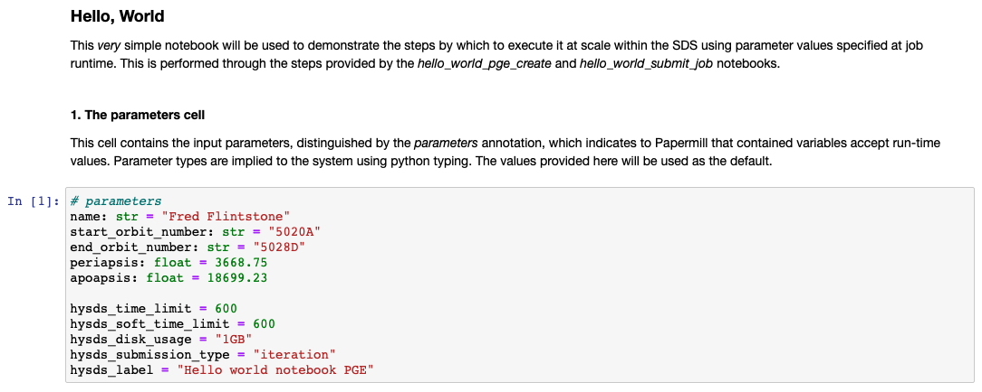

If the tag isn’t visible (similar to the above), turn on the cell tag visibility through the View menu bar selection:

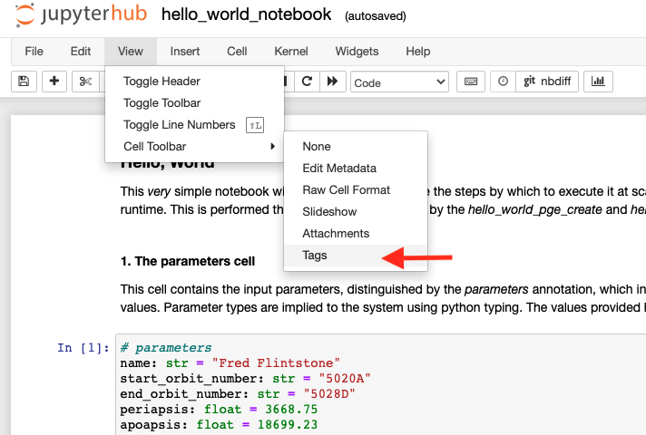

after which the tag should become visible:

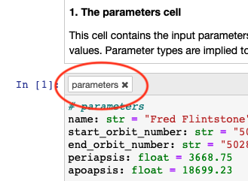

As discussed in 2.2.5 Notebook #4 - DEM Notebook through Papermill, the variables declared in the cell tagged with this annotation become run-time inputs when the notebook is executed as a stand-alone through Papermill (and by extension, they become run-time inputs to the SDS job).

In this notebook the parameters are; *name*, *start_orbit_number*, *end_orbit_number*, *periapsis*, and *apoapsis*. Also note some additional parameters, prefixed with *hysds_*. As their names imply, these are used in the context of SDS execution (refer to the HySDS documentation for a full description of these parameters).

It is important to examine the syntax of the variable declarations, for example, that for *periapsis*:

periapsis: float = 3668.75

The python typing used in these declarations convey to the SDS the parameter value types. If no type is specified, text/string is used. Additionally, the value provided in the declaration is used as the default value.

The second cell and onward perform a series of meaningless yet demonstrative manipulations of the parameters.

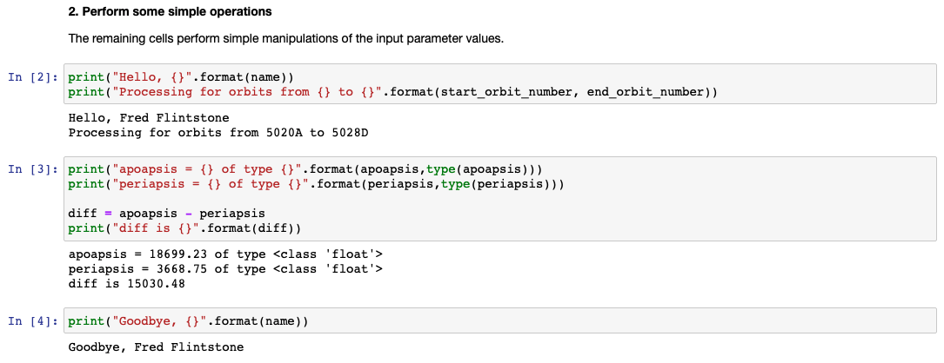

### 2.3.5 Generating the Job Files

The steps used to generate the job files, commit them and build the SDS job are provided in the *hello_world_pge_create.ipynb* notebook, found in the project root directory.

Step 1 – Set-up

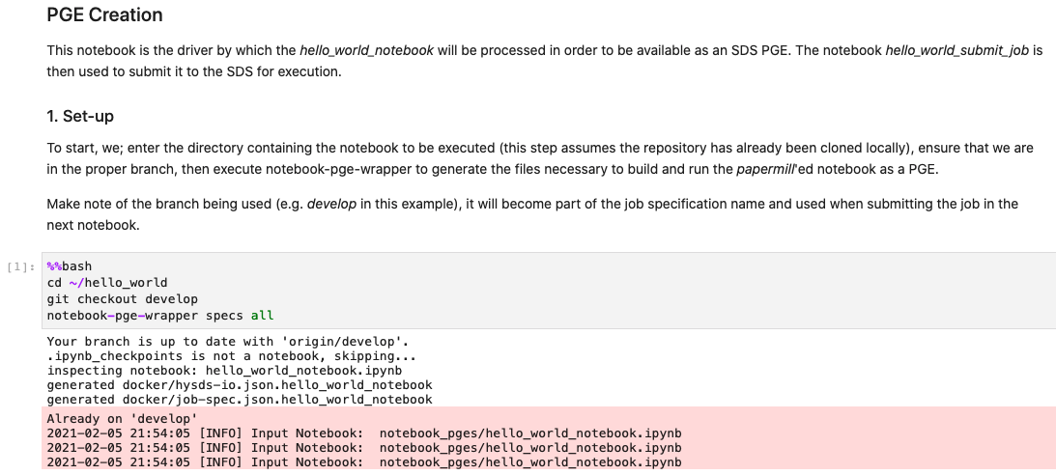

This step makes sure the current directory is that of the project, (possibly redundantly) checks out the *develop* branch, then invokes *notebook-pge-wrapper* *specs all* to generate the SDS job files for the notebooks found in the *notebook_pges* directory (which is currently the above example notebook).

The files produce by *notebook-pge-wrapper* are placed in the *docker* subdirectory:

* hysds-io.json.hello_world_notebook – The json descriptor of the SDS job input parameters’ source, name, type and default value - as obtained from the *#parameters* cell in the *hello_world_notebook*.
* job-spec.json .hello_world_notebook – The json descriptor of the SDS job, including the execution command, runtime limits and the destinations of the input parameters (i.e. how they are made available to the job).

Step 1a – Manual Edit

The next step is to perform a necessary manual edit using a Jupyter terminal window. Move to the hello_world/dockerfile directory and open the Dockerfile. Within it you will see:

…

&& $CONDA_DIR/bin/pip install -e .

USER jovyan

# copy your repo into the docker container

################################################

#COPY . $HOME/<repo name>

################################################

WORKDIR $HOME

CMD ["/bin/bash", "--login"]

Uncomment and edit the line beginning with “# COPY “ to:

COPY . $HOME/hello_world

and save/close the file.

Step 2 – Commit Changes

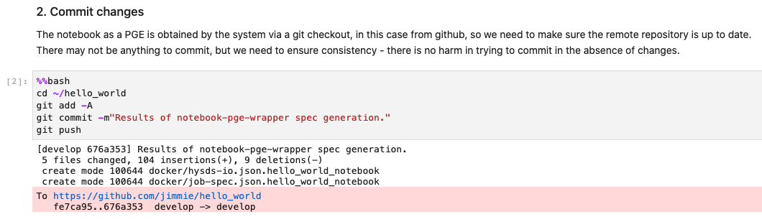

This step stages all changed files, makes the commit and pushes them to the remote where they can be picked up by the build system.

Step 3 – Initialize the SDS (Build) API

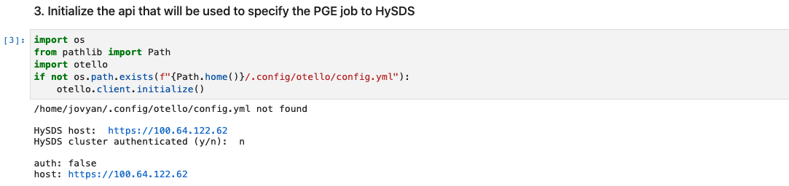

Here the SDS API, which will be used to define and submit the job build, is initialized. If the config file (*~/.config/otello/config.yml*) does not already exist, you will be prompted for; the HySDS endpoint (i.e. the IP address of the mozart instance), whether the HySDS cluster is utilizing authentication. If yes, you will be prompted for a user name and password.

Step 4 – Create the build system handle

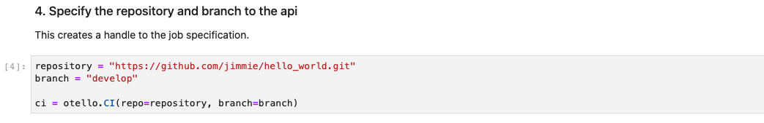

Now a (logical) handle to the build system is created, passing in the repository URL (which you will have to modify to point to your own that you created earlier) and branch.

Step 5 – Register the build

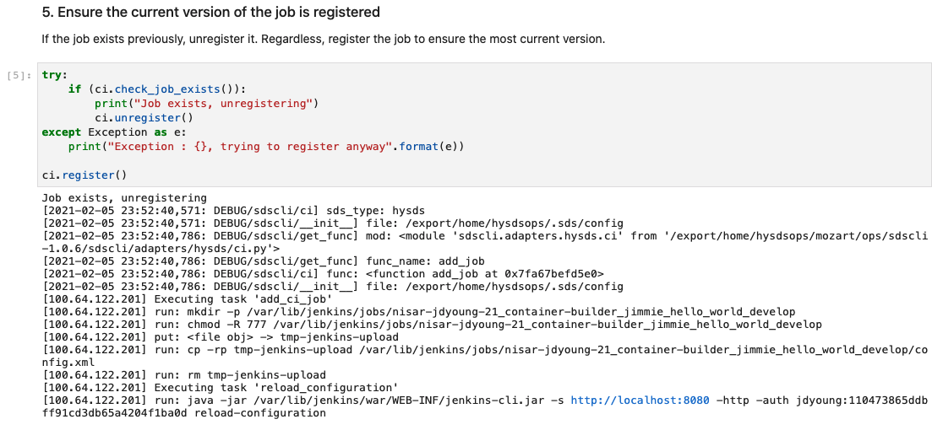

Using the build system handle, a check is made to see if a previous version of the job build exists. If it does, it is removed. Either way, the latest version of the job build is then registered.

Step 6 – Initiate the build

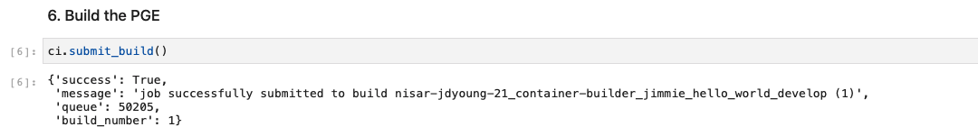

This step initiates the build. This is performed asynchronously and immediately returns.

Step 7 – Wait for the build to complete

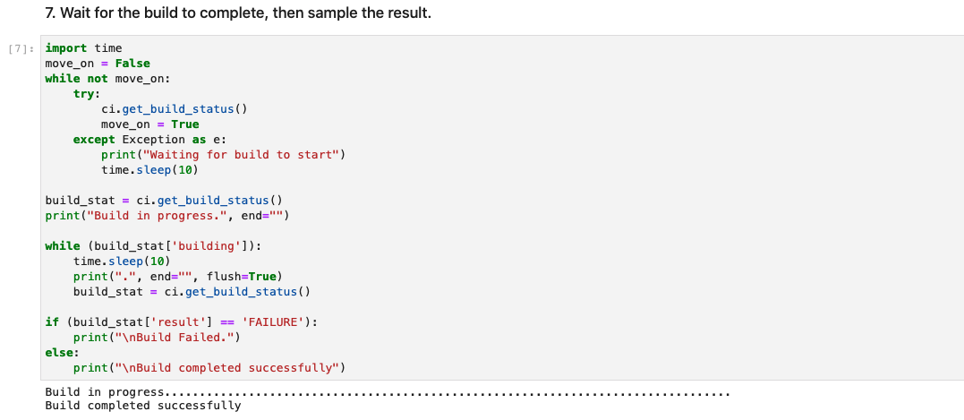

The build takes a few minutes to complete (feel free to go refresh your coffee), after which the results are displayed.

Step 8 – Final build results

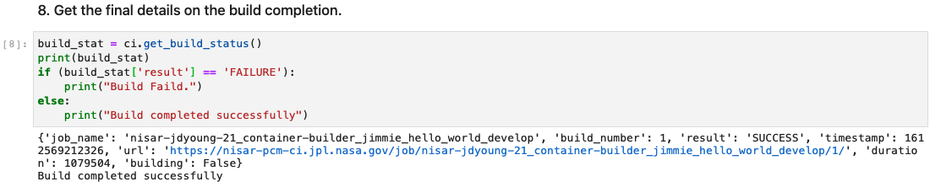

Here a more detailed summary of the final build status is displayed.

At this point, you are ready to execute the notebook within the SDS.

### 2.3.6 Executing the notebook PGE

Now that the job has been built, it can be executed within the SDS. We will walk through the *hello_world_submit_job.ipynb* (also in the project root directory) to see how this is performed.

Step 1 – Initialize the API

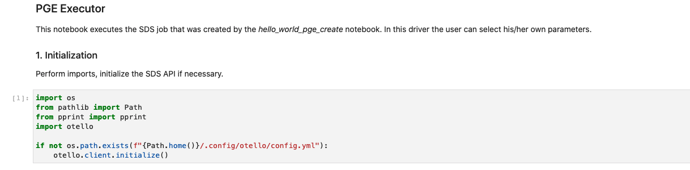

As you did with the previous notebook, a check is made to see if the SDS API needs to be initialized. Since the configuration was saved from before, you won’t have to re-enter the values.

Step 2 – Create a handle to the job executor



The endpoint is taken from the config checked in the previous step.

Step 3 – Initialize the job handle

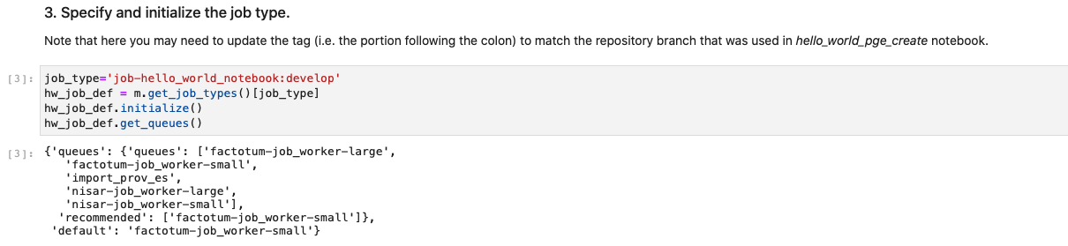

The name of the job is used to create a job handle and retrieve job queue information from the executor. The job name, automatically generated when built, assume the form of *job-<notebook name>:<branch>*. The information displayed includes the list of available queues and the recommended and default queues for the job type.

Step 4 – Display the job metadata

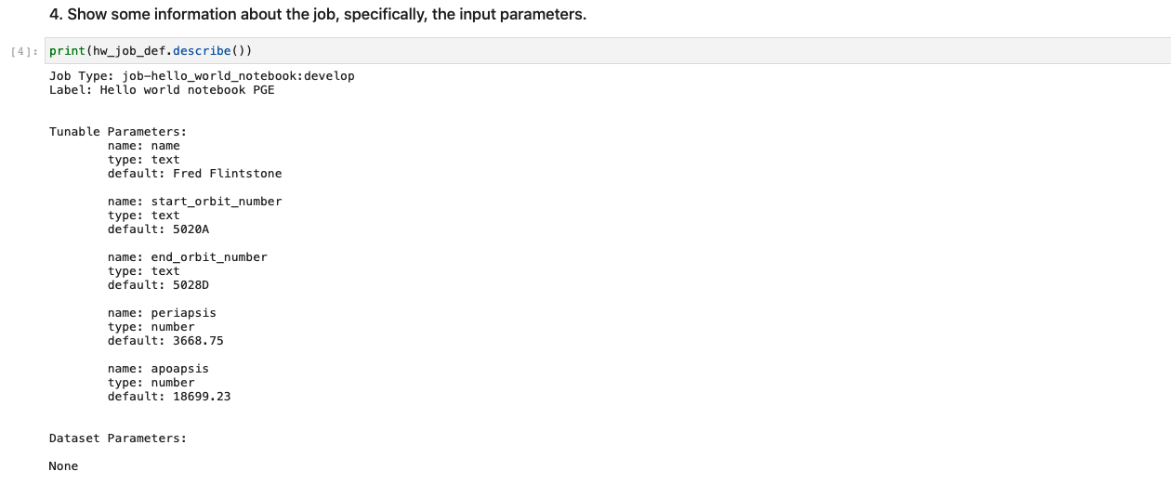

When the job handle was initialized in the previous step, it also retrieved metadata about the job. In this step, details about the job are displayed; job type, the label assigned at built-time and information about the input parameters (name, type and default value).

Step 5 – Current input parameter values

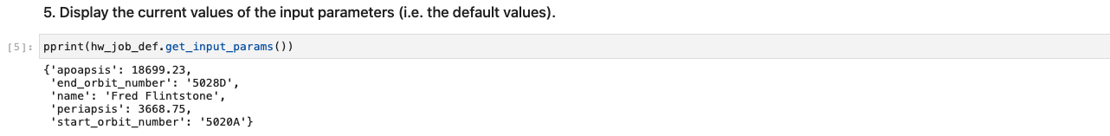

Before specifying new values for the input parameters, the current (i.e. default) values are displayed.

Step 6 – Prompt for new input parameter values

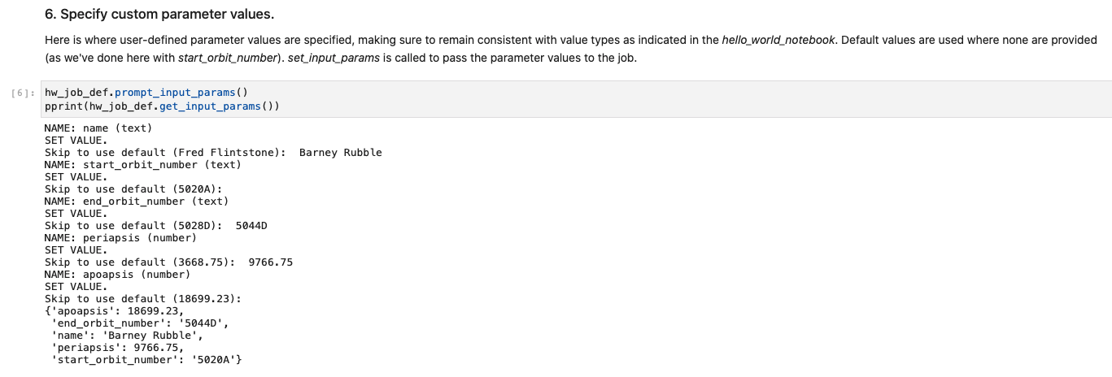

The helper function *prompt_input_params()* presents a prompt for each of the job’s input parameters and includes the default value. In the dialog captured in the above image, default values were accepted for *start_orbit_number* and *apoapsis*, which are reflected in the resulting set of parameter values that are displayed at the end of the cell.

Step 7 – Submit the job



As with building the job, the job execution is initiated asynchronously so *submit_job*() returns immediately. In the invocation above, we chose to provide overriding values for the job queue, and a custom tag value. An optional *priority* argument is also available.

Note that for the On-Demand Beta, only the nisar-job_worker-small queue has been enabled, be sure to only use that queue.

Step 8 – Job completion

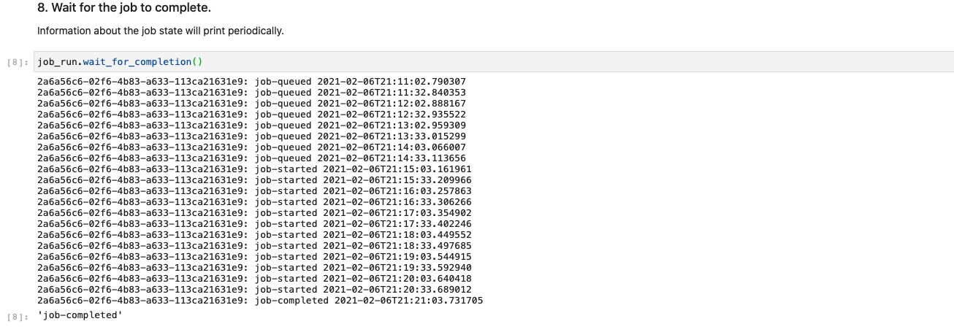

This step waits for the job to complete. The above run was on a cold-started SDS so the time to complete was rather high since the job worker had to be spun up and the job’s docker image had to be downloaded.

From the notebook perspective, the completion of this particular job is somewhat anticlimactic. Checking the job execution on the executor console (aka ‘Figaro’), the following has been captured:

2021-02-06 21:20:42 [INFO] Executing notebook with kernel: python3

2021-02-06 21:20:42 [INFO] Executing Cell 1---------------------------------------

2021-02-06 21:20:42 [INFO] Ending Cell 1------------------------------------------

Executing: 11%|█ | 1/9 [00:01<00:10, 1.27s/cell]2021-02-06 21:20:42 [INFO] Executing Cell 2---------------------------------------

2021-02-06 21:20:42 [INFO] Ending Cell 2------------------------------------------

2021-02-06 21:20:43 [INFO] Executing Cell 3---------------------------------------

2021-02-06 21:20:43 [INFO] Ending Cell 3------------------------------------------

2021-02-06 21:20:43 [INFO] Executing Cell 4---------------------------------------

2021-02-06 21:20:43 [INFO] Ending Cell 4------------------------------------------

2021-02-06 21:20:43 [INFO] Executing Cell 5---------------------------------------

2021-02-06 21:20:43 [INFO] Ending Cell 5------------------------------------------

2021-02-06 21:20:43 [INFO] Executing Cell 6---------------------------------------

2021-02-06 21:20:43 [INFO] Hello, Barney Rubble

Processing for orbits from 5020A to 5044D

2021-02-06 21:20:43 [INFO] Ending Cell 6------------------------------------------

2021-02-06 21:20:43 [INFO] Executing Cell 7---------------------------------------

2021-02-06 21:20:43 [INFO] apoapsis = 18699.23 of type <class 'float'>

periapsis = 9766.75 of type <class 'float'>

diff is 8932.48

2021-02-06 21:20:43 [INFO] Ending Cell 7------------------------------------------

2021-02-06 21:20:43 [INFO] Executing Cell 8---------------------------------------

2021-02-06 21:20:43 [INFO] Goodbye, Barney Rubble

2021-02-06 21:20:43 [INFO] Ending Cell 8------------------------------------------

Executing: 89%|████████▉ | 8/9 [00:01<00:00, 1.12cell/s]2021-02-06 21:20:43 [INFO] Executing Cell 9---------------------------------------

2021-02-06 21:20:43 [INFO] Ending Cell 9------------------------------------------

Executing: 100%|██████████| 9/9 [00:01<00:00, 5.67cell/s]

Note that the expected parameter values have been used.

Once again, congratulations. You have successfully executed a notebook within the SDS!

### A More Representational Notebook for At-Scale Execution

For this section, we’re returning back to the original *nisar-on-demand-use-cases* directory/repository and now that you’ve gone through the steps by which a notebook can be run at scale, you may notice some now familiar sub-directories within *nisar-on-demand-use-cases* (namely, *notebook_pges* and *docker*).

The *topsApp.ipynb* notebook has been previously processed w/ the *notebook-pge-wrapper* to produce the necessary *Dockerfile*, *I/O* and *job-spec* files. The job/PGE construction (along the lines of what was performed in Section 2.3.5 for the simple example) is performed by the *create_topsApp_job.ipynb* notebook (found in the base directory), the job submission (along the lines of what was performed in Section 2.3.6 for the simple example) is performed by the *submit_topsApp_job.ipynb* notebook.

To this point, this document should have prepared you to identify the cell in *notebook_pges/topsApp.ipynb* that has been annotated with the *parameters* tag and how to follow along with the job creation and submission processes provided by the above mentioned driver notebooks.

Once again, be sure that only the *nisar-job_worker-small* queue is used in the context of the On-Demand Beta period.

## JupyterLab

**Summary:** This optional section provides an overview of JupyterLab, the latest user interface for the execution and management of Notebooks, as well as some capabilities it enables. Read this if you are interested in this UI and/or the GitLab extension.

JupyterLab is a next-generation web UI for Notebooks. Compared to the original Jupyter Notebook interface as used above, the JupyterLab interface is more self-contained employing its own tabs (as opposed to browser tabs) to present notebooks, terminals and other editors. More information, including an overview video can be found at:

<https://jupyterlab.readthedocs.io/en/stable/getting_started/overview.html>

Note that the use of JupyterLab at this point in time is entirely optional. It is presented here under the assumption that it will become the de-facto Jupyter Notebook interface as well as to present the Git extension available only through JupyterLab.

### 2.4.1 Enabling JupyterLab

JupyterLab has been included in the server’s Docker stack (image version r1.3 and newer) on the NISAR JupyterHub.

All on-demand systems should be directed to the UI by the default upon logging into the on-demand system so manually enabling the UI (by adding /lab to the initial server URI) should not be necessary anymore.

Below is an example view of the JupyterLab layout. The Launcher can be used to open new notebooks, consoles, terminals and editors. Note how all open items are in JupyterLab level tabs as opposed to separate browser tabs.

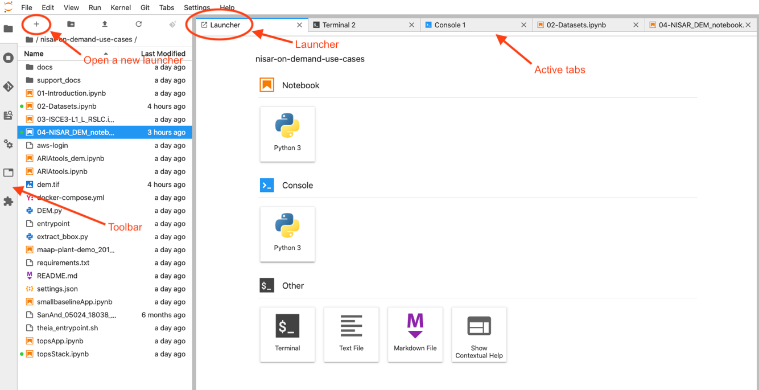

### 2.4.2 The Toolbar

The toolbar contains icons for tools that were (mostly) available as menu options in the legacy Jupyter interface with a couple of additions.

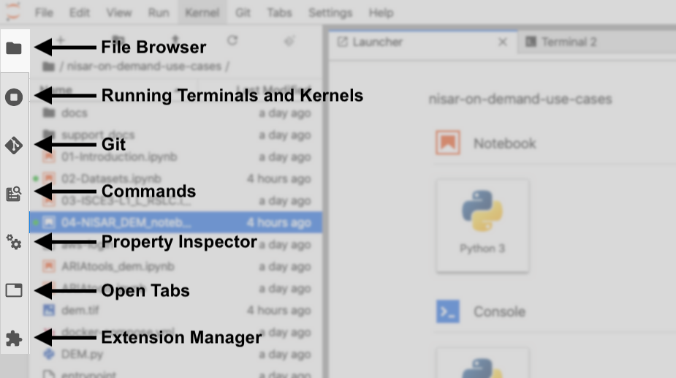

**File Browser** provides the ability to navigate throughout the ~jovyan home directory and its subdirectories. **Running Terminals and Kernels** is self-explanatory. **Git** is an extension that provides the ability to interact with repositories without having to use command lines in a Terminal. It is explained further below in 2.3.4 Git Extension. **Commands** provides a list of commands that are available to use, those that are active and inactive varies based on context; namely, the active tab. **Property Inspector** provides a context sensitive list of properties for the currently select object – see 2.3.3 Viewing cell tags below for an example. **Open Tabs** provides a list of tabs that are currently open, selecting one immediately navigates to it. **Extension Manager** allows the inspection of installed extensions (such as that for Git, above) as well as the ability to install/enable others.

### 2.4.3 Viewing cell tags

Unlike the legacy notebook interface, JupyterLab does not show cell tags inline. Instead, the following steps must be performed to view and/or edit tags for a particular cell. For this example, the cell tagged with ‘parameters’ in 2.2.5 Notebook #4 - DEM Notebook through Papermill will be used.

1. Select the cell by clicking somewhere inside of it.
2. In the left toolbar, select the property inspector tool (the two cogs).
3. The currently set tag, along with a widget to add another tag, is shown.

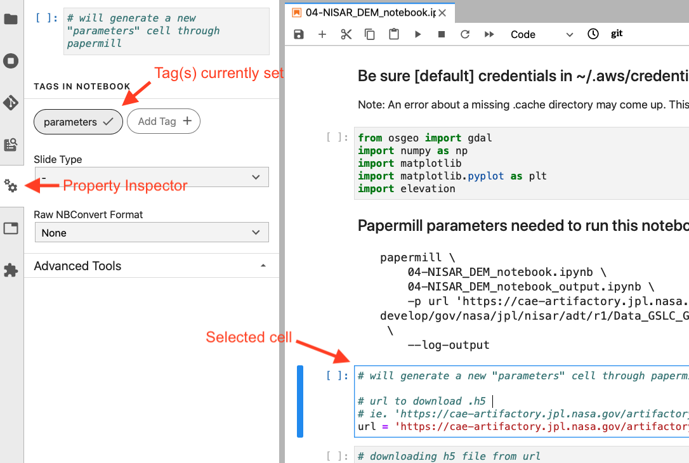

Note that all tags present in the current notebook are listed, but those that are applicable to the currently selected cell is bolded.

### 2.4.4 Git Extension

As noted in the Toolbar discussion, the Git Extension enables repository manipulation (initialize, clone, push/pull, etc) through the UI without needing to open a Terminal and typing in git commands.

The extension is cognizant of whether the current directory (as indicated in the File Browser) is in a git repository. If it isn’t, the following high level actions are made available:

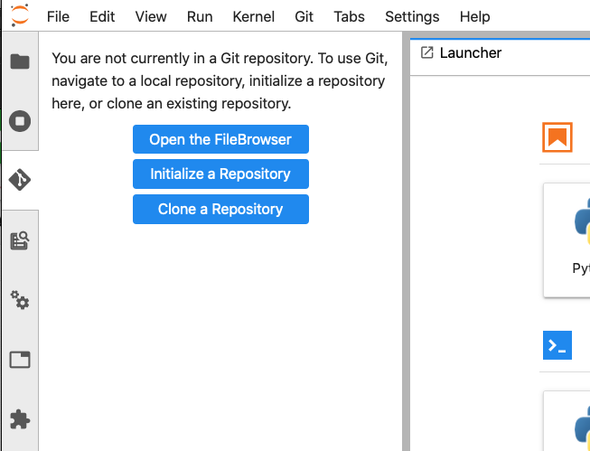

Note that “Initialize a Repository” operates as if the current directory is to be initialized (i.e. it does not create a new directory). Make sure you have navigated to the appropriate directory using the File Browser before initializing.

As an example, we will create an example repository ‘test_repo’ by first creating the associated directory in the File Browser:

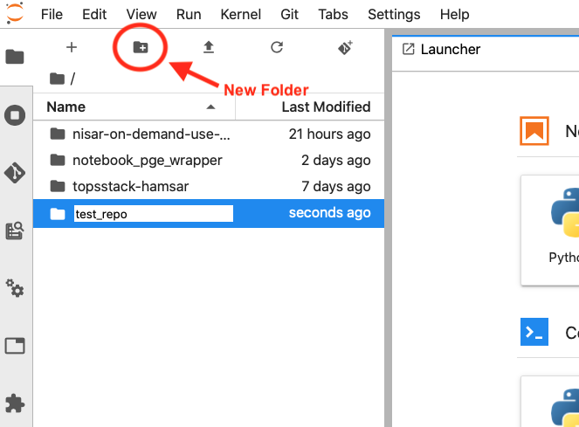

After entering the new folder/directory name, double click on the folder to enter it. Then select the Git tool and select “Initialize a Repository”. You will be asked to confirm the action:

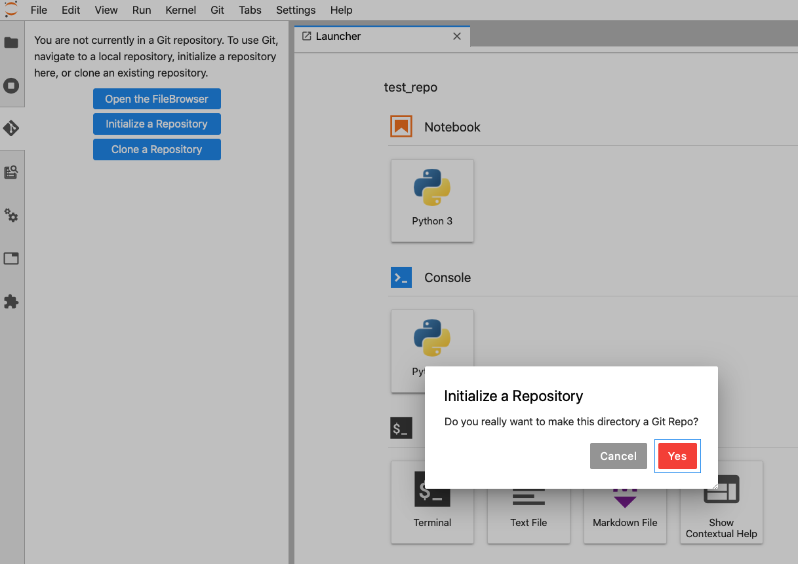

Once confirmed, you will be presented with the Git repository view:

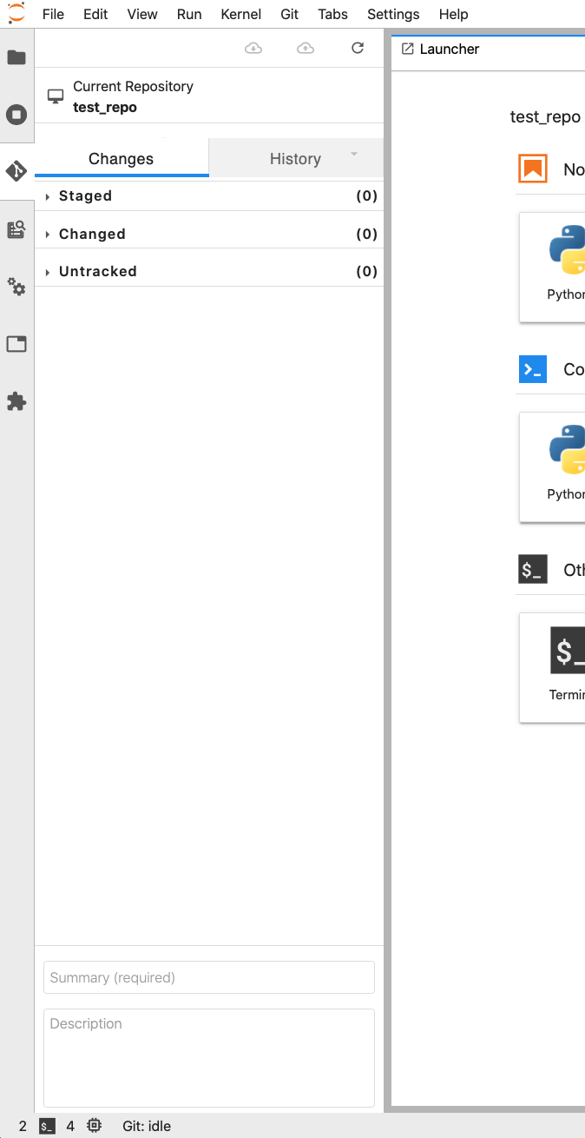

For the sake of this example, open a Terminal window, move to the test_repo directory and create an empty file:

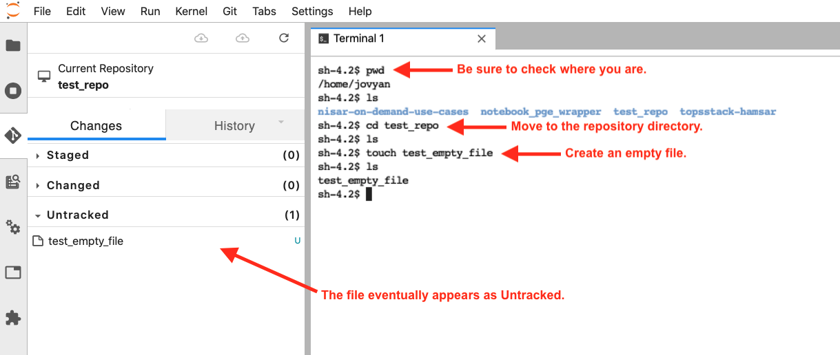

At this point the file is untracked. To promote it to tracked, hover over the file and select the Track icon (the plus sign – ‘+’).

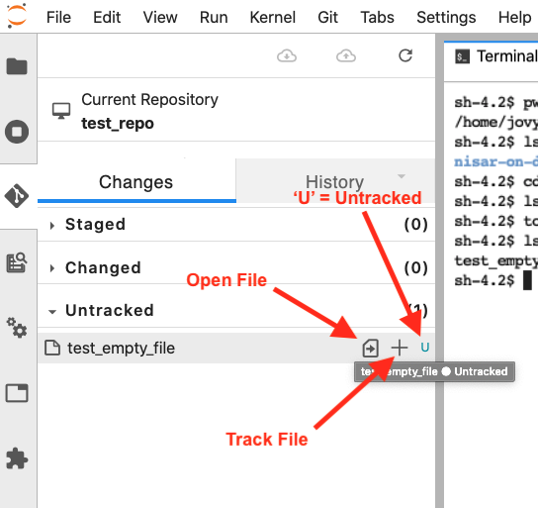

Once tracked, the file will move to the ‘Staged’ list. Hovering over the file at this point provides icons to open, diff and untrack the file. To commit, enter a commit Message (and optionally, a Description) in the Summary text box at the bottom of the Git command panel and press “Commit”.

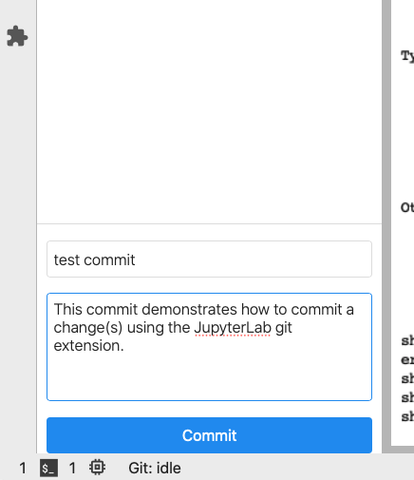

Unless you have set the git user.name and user.email config values using the git command line (this can be performed in a terminal), you will be prompted for a name and email to attach to the commit.

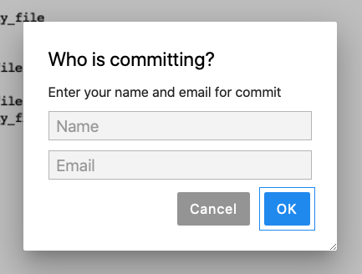

If the repository has been associated with a remote, the pull and push icons are active, otherwise they are grayed out. The refresh icon which accelerates the detection of changes, is always active.

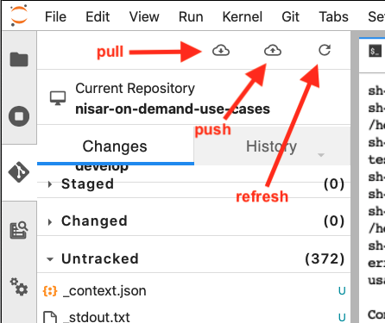

Note that on Safari, the layout of the Git panel is somewhat obscured:

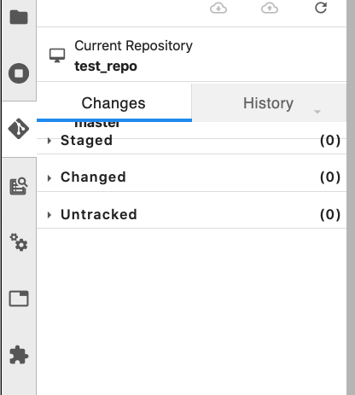

as compared to that on Chrome:

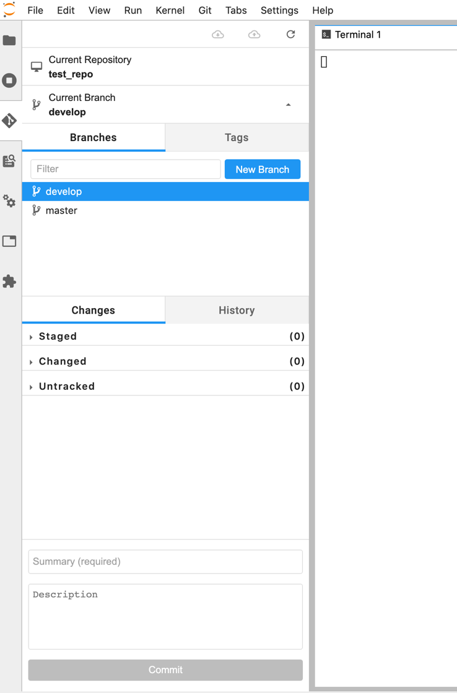

which shows the ability to change and create branches.

Additional commands are available in the Git menu in the top menu bar.

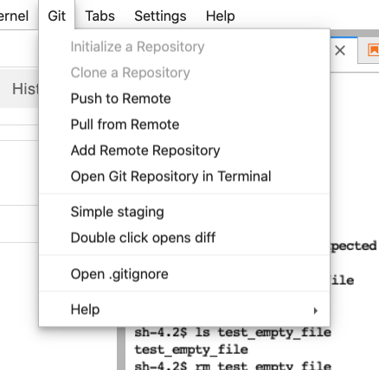

1. Acronyms

ADE – Algorithm Development Environment

ADT – Algorithm Development Team

API - Application Programming Interface

AWS - Amazon Web Services

Cal/Val - Calibration/Validation

DEM - Digital Elevation Model

DOS - Denial of Service (attack)

ENVI - Environment for Visualizing Images (software)

GDAL - Geospatial Data Abstraction Library

GPU - Graphical Processing Unit

HDF5 - Hierarchical Data Format (Version 5)

HySDS - Hybrid Cloud Science Data System Framework

ISCE - InSAR Scientific Computing Environment

ISRO – Indian Space Research Organization

JPL – Jet Propulsion Laboratory

NISAR – NASA-ISRO SAR Mission

PCM – Processing Control and Management

PGE – Product Generation Executable

REST - Representational State Transfer

S3 – AWS Simple Storage Services

SAR – Synthetic Aperture Radar

SDS – Science Data System

SLC – Single Look Complex

SSO - Single Sign-On

TOPS – Terrain Observation by Progressive Scan

URL - Uniform Resource Locator

VPN - Virtual Private Network